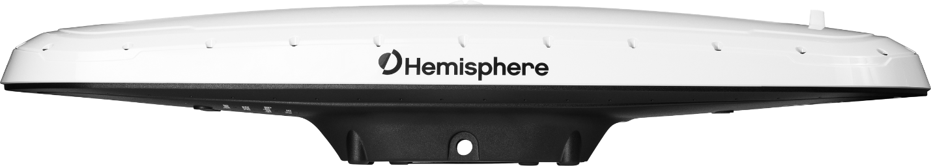

875-0376-0 Vector™ V500

GNSS Smart Antenna

User Guide

Revision: A3 January 14, 2020

**Table of Contents**

Device Compliance, License and Patents 4

V500 Terms & Definitions 6

Chapter 1: Introduction 10

Overview 10

Product Overview 11

Key Features 13

What’s Included in Your Kit 14

Firmware Upgrades 15

Chapter 2: Installing the V500 20

Overview 20

Mounting the V500 21

Ports 32

Selecting Baud Rates and Message Types 34

Connecting the V500 to External Devices 34

Chapter 3: Understanding the V500 39

Overview 39

Differential and RTK Operation 40

SBAS Tracking 40

Athena RTK 41

Atlas L-band 42

Supported Constellations 42

Supplemental Sensors 43

Time Constants 45

Chapter 4: Operating the V500 48

Overview 48

Powering the Receiver On/Off 49

LED Indicators 50

Configuring the V500 Using the WebUI 51

Appendix A: Troubleshooting 73

Overview 73

Troubleshooting 74

Appendix B: Technical Specifications 77

Technical Specifications 77

V500 Technical Specifications 78

Index 82

End User License Agreement 84

Warranty Notice 88

## Device Compliance, License and Patents

|  |  |
| --- | --- |
| **Device Compliance** | This device complies with part 15 of the FCC Rules. Operation is subject to the following two conditions:   1. This device may not cause harmful interference, and 2. this device must accept any interference received, including interference that may cause undesired operation.   This product complies with the essential requirements and other relevant provisions of Directive 2014/53/EU. The declaration of conformity may be consulted at [HTTPS://HEMISPHEREGNSS.COM/ABOUT-US/QUALITY-COMMITMENT.](https://hemispheregnss.com/About-Us/Quality-Commitment) |

|  |  |
| --- | --- |
| **Copyright Notice** | Copyright Hemisphere GNSS, Inc. (2020). All rights reserved.  No part of this manual may be reproduced, transmitted, transcribed, stored in a retrieval system or translated into any language or computer language, in any form or by any means, electronic, mechanical, magnetic, optical,  chemical, manual or otherwise, without the prior written permission of Hemisphere GNSS. |

|  |  |
| --- | --- |
| **Trademarks** | Hemisphere GNSS®, the Hemisphere GNSS logo, TRACERTM, Crescent®, EclipseTM, e-Dif®, L-DifTM, PocketMax4TM,  S320TM, SBX-4TM, VectorTM, XF1TM, and XF2TM are proprietary trademarks of Hemisphere GNSS, Inc. Other  trademarks are the properties of their respective owners. |

**Patents** Hemisphere GNSS products may be covered by one or more of the following patents:

|  |  |  |  |
| --- | --- | --- | --- |
| **Patents** |  |  |  |
| 6111549 | 6876920 | 7400956 | 8000381 |
| 6397147 | 7142956 | 7429952 | 8018376 |
| 6469663 | 7162348 | 7437230 | 8085196 |
| 6501346 | 7277792 | 7460942 | 8102325 |
| 6539303 | 7292185 | 7689354 | 8138970 |
| 6549091 | 7292186 | 7808428 | 8140223 |
| 6711501 | 7373231 | 7835832 | 8174437 |
| 6744404 | 7388539 | 7885745 | 8184050 |
| 6865465 | 7400294 | 7948769 | 8190337 |
| 8214111 | 8217833 | 8265826 | 8271194 |
| 8307535 | 8311696 | 8334804 | RE41358 |

|  |  |
| --- | --- |
| **Australia Patents** |  |
| 2002244539 | 2002325645 |
| 2004320401 |  |

*Continued on next page*

|  |  |
| --- | --- |
| **Notice to Customers** | Contact your local dealer for technical assistance. To find the authorized dealer near you:  Hemisphere GNSS, Inc 8515 East Anderson Drive Scottsdale, AZ 85255 USA Phone: (480) 348-6380  Fax: (480) 270-5070  [PRECISION@HGNSS.COM](mailto:precision@hgnss.com)  [WWW.HGNSS.COM](http://www.hgnss.com/) |

|  |  |
| --- | --- |
| **Technical Support** | If you need to contact Hemisphere GNSS Technical Support:  Hemisphere GNSS, Inc. 8515 East Anderson Drive Scottsdale, AZ 85255 USA Phone: (480) 348-6380  Fax: (480) 270-5070  [SUPPORT.HGNSS.COM](mailto:techsupport@hgnss.com) |

|  |  |
| --- | --- |
| **Documentation**  **Feedback** | Hemisphere GNSS is committed to the quality and continuous improvement of our products and services. We  urge you to provide Hemisphere GNSS with any feedback regarding this guide by opening a support case at the  following website: [HGNSS.COM](http://www.hgnss.com/) |

|  |  |
| --- | --- |
| **Introduction** | The following table lists the terms and definitions used in this document. |

**V500 terms & definitions**

|  |  |
| --- | --- |
| **Term** | **Definition** |
| 1PPS | 1 pulse-per-second is a pulse output by the receiver precisely once per second and is used for hardware  synchronization. |
| Activation | Activation refers to a feature added through a one-  time purchase. For features that require recurring fees, see Subscription. |
| Atlas | Atlas is a subscription-based service provided by Hemisphere that enables the V500 to achieve sub- decimeter accuracy without a base station or  datalink. |
| Base Station | The Base Station is a receiver placed over a familiar point, provides real-time observations, and sends those observations to nearby RTK rovers via the  internet. |
| BeiDou | BeiDou is a Chinese satellite-based navigation system. |
| CAN | Controller Area Network |
| DGPS/DGNSS | Differential GPS/GNSS refers to a receiver using  Differential Corrections. |
| Differential Corrections | A method of improving precision of a GNSS rover. Two GNSS receivers placed in a nearby area will have similar error. A base station is placed over a known  point. |

*Continued on next page*

**V500 terms & definitions**, continued

|  |  |
| --- | --- |
| **Term** | **Definition** |
| Elevation Mask | Elevation Mask is the minimum angle between a satellite and the horizon for the receiver to use that  satellite in the solution. |
| EMC | Electromagnetic compatibility (EMC) is the ability of electrical equipment and systems to function in their electromagnetic environment, by limiting the unintentional generation, propagation and reception of electromagnetic energy which may cause unwanted effects such as electromagnetic interference (EMI) or even physical damage in operational equipment. |
| Firmware | Firmware is the software loaded into the receiver that controls the functionality of the receiver and  runs the GNSS engine. |
| GALILEO | Galileo is a global navigation satellite system implemented by the European Union and European  Space Agency. |
| GLONASS | Global Orbiting Navigation Satellite System  (GLONASS) is a Global Navigation Satellite System deployed and maintained by Russia. |
| GNSS | Global Navigation Satellite System (GNSS) is a system that provides autonomous 3D position (latitude, longitude, and altitude) and accurate timing globally by using satellites. Current GNSS providers are: GPS, GLONASS and Galileo. |
| GPS | Global Positioning System (GPS) is a global navigation satellite system implemented by the  United States. |
| Heading | Heading is the angle between true north and the vector calculated from the primary to secondary  antenna. |
| Heading Bias | Heading Bias is an offset applied to the heading  value calculated by the receiver. |

*Continued on next page*

**V500 terms & definitions**, continued

|  |  |
| --- | --- |
| **Term** | **Definition** |
| IRNSS | The Indian Regional Navigation Satellite System, an autonomous regional satellite navigation system that provides accurate real-time positioning and timing  services. |
| mFreq | Multi-frequency |
| Multipath | Multipath occurs when the GNSS signal reaches the antenna by two or more paths. This causes incorrect pseudo-range measurements and leads to less  precise GNSS solutions. |
| NMEA | National Marine Electronics Association (NMEA) is a marine electronics organization that sets standards  for communication between marine electronics. |
| ppm | Pulse per minute |
| QZRSS | Quasi-Zenith Satellite System, a four satellite regional time transfer system and a satellite-based  augmentation system developed by Japan |
| ROX | ROX is a Hemisphere GNSS propriety RTK message format that can be used as an alternative to RTCM3 when both the base and rover are Hemisphere  branded. |
| RTK | Real-Time-Kinematic (RTK) is a real-time differential GPS method that provides better accuracy than  differential corrections. |
| SBAS | Satellite Based Augmentation System (SBAS) is a system that provides differential corrections over  satellite throughout a wide area or region. |
| SNR | Signal-to-noise ratio is a measure used in science and engineering that compares the level of a desired signal to the level of background noise. |
| Subscription | A subscription is a feature that is enabled for a limited time. Once the end-date of the subscription has been reached, the feature will turn off until the  subscription is renewed. |

*Continued on next page*

**V500 terms & definitions**, continued

|  |  |
| --- | --- |
| **Term** | **Definition** |
| UHF | Ultra high frequency is the ITU designation for radio frequencies in the range between 300 megahertz (MHz) and 3 gigahertz (GHz), also known as the decimetre band as the wavelengths range from one  meter to one tenth of a meter (one decimeter). |
| WAAS | Wide Area Augmentation System (WAAS) is a satellite-based augmentation system (SBAS) that provides free differential corrections over satellite in  parts of North America. |

**Overview**

# Chapter 1: Introduction

|  |  |
| --- | --- |
| **Introduction** | This User Guide provides information to help you quickly set up your Vector  V500 GNSS Smart Antenna™. You can download this manual from the Hemisphere GNSS website at [WWW.HGNSS.COM.](http://www.hgnss.com/) |

**Contents**

|  |  |
| --- | --- |
| **Topic** | **See Page** |
| Product Overview | 11 |
| Key Features | 13 |
| What’s Included in Your Kit | 14 |
| Firmware Upgrades | 15 |

## Product Overview

|  |  |
| --- | --- |
| **Product**  **overview** | Based on Eclipse Vector™ GNSS technology, the V500 (Figure 1-1) is  designed for marine applications that require precise heading and RTK position performance.  The V500 is designed to withstand the stringent Marine EMC and Environmental requirements. It offers support for BT/Wi-Fi, Ethernet, CAN, RS-422, and RS-232. An optional external UHF radio can be connected.  Featuring an all-in-one Hemisphere GNSS Eclipse Vector-based receiver and two integrally separated antennas, with a baseline of 50 cm, the V500 achieves heading accuracy of up to 0.2º RMS (depending on environmental conditions) and offers robust positioning performance.  A close up of a device  Description automatically generated  **Figure 1-1 V500 Smart Antenna** |

*Continued on next page*

|  |  |
| --- | --- |
| **Product**  **overview**, continued | The V500 provides accurate and reliable heading and position information  at high update rates by using a high performance GNSS receiver and two antennas for GNSS signal processing.  One antenna is designated as the primary GNSS antenna, and the other antenna is the secondary GNSS antenna. Positions computed by the V500 are referenced to the phase center of the primary GNSS antenna. Heading data references the Vector formed from the primary GNSS antenna phase center to the secondary GNSS antenna phase center.  The standard model V500 tracks GPS, GLONASS, Galileo, BeiDou, and QZSS satellites.  The V500 can be upgraded via activations or subscriptions to support:   * Multi-frequency * Athena RTK * Atlas L-band |

|  |  |
| --- | --- |
| **Athena RTK** | Athena RTK (Real Time Kinematic) technology is available on Eclipse-based  GNSS receivers. This is Hemisphere's most advanced RTK software and can be added to the V500 as an activation.  Athena RTK has the following benefits:   * **Improved Initialization time -** Performing initializations in less than 15 seconds at better than 99.9% of the time * **Robustness in difficult operating environments -** Extremely high productivity under the most aggressive of geographic and landscape- oriented environments * **Performance on long baselines -** Industry-leading position stability for long baseline applications |

*Continued on next page*

|  |  |
| --- | --- |
| **Atlas L-band** | Atlas L-band is Hemisphere's industry leading correction service, which can  be added to the V500 as a subscription. Atlas L-band has the following benefits:   * **Positioning accuracy -** Competitive positioning accuracies down to 4 cm RMS in certain applications * **Positioning sustainability -** Cutting edge position quality maintenance in the absence of correction signals, using Hemisphere’s patented technology * **Scalable service levels -** Capable of providing virtually any accuracy, precision and repeatability level in the 4 cm to 50 cm range * **Convergence time -** Industry-leading convergence times of 10-40 minutes |

|  |  |
| --- | --- |
| **For more**  **information** | For more information about Athena RTK, see:  <http://hemispheregnss.com/Technology>  For more information about Atlas L-band, see:  <http://hemispheregnss.com/Atlas> |

## Key Features

|  |  |
| --- | --- |
| **V500 key**  **features** | Key features of the V500 include:   * Simple all-in-one RTK-capable * Multi-frequency GPS/GLONASS/BeiDou/Galileo/QZRSS/IRNSS * Athena™ RTK and Atlas® L-band capable * Supports Ethernet, CAN, Serial, Bluetooth, and Wi-Fi * Powerful WebUI accessed via Wi-Fi * Fully rugged solution for the harshest environments |

|  |  |
| --- | --- |
| **V500 kit** | Table 1-1 lists the parts included with your V500. The V500 GNSS Smart  Antenna and the power/data cable (accessory item) are the only two required components.  **Note:** The V500’s parts comply with IEC 60945 Section 4.4: “Exposed to the weather.” |

**V500 Parts list Table 1-1 V500 Parts list**

|  |  |
| --- | --- |
| **Part No.** | **Description** |
| 752-0027-10 | Vector V500 GNSS Compass |
| 940-3119-10 | Vector V500 GNSS Compass kit |
| 150-0056-10 | BT/Wi-Fi antenna |

All the following items are available for purchase separately from your V500 receiver:

|  |  |
| --- | --- |
| **Part No.** | **Description** |
| 051-0398-10 | 3m power/data cable (unterminated) |
| 051-0398-20 | 15m power/data cable (unterminated) |
| 710-0152-10 | 22-Pin to 18-Pin adapter kit |
| 150-0056-10 | BT/Wi-Fi antenna |
| 163-1007-000 | Eclipse 20Hz activation |
| 163-1004-000 | Eclipse mFreq activation |
| 163-1045-0 | Athena RTK activations |
| Multiple | Atlas subscriptions |

|  |  |
| --- | --- |
| **Overview** | Periodically, Hemisphere GNSS releases firmware upgrades to improve  performance, fix bugs, or add new features to a product. To update the firmware on the V500, choose from one of two options:   1. Download the latest version of Hemisphere GNSS RightArm from the following link:   <https://hemispheregnss.com/Resources-Support/Software>   1. Use the internal WebUI. |

|  |  |
| --- | --- |
| **RightArm**  **Updates** | Connect the V500 to a computer over serial. Firmware can be loaded over  either serial port. Set the baud rate of the serial port you are using to 19200.  Launch RightArm.  Click the **Connect** button or navigate to Receiver -> Connect. |

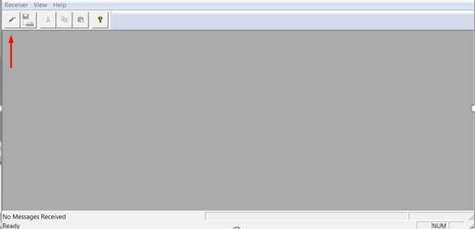

*Continued on next page*

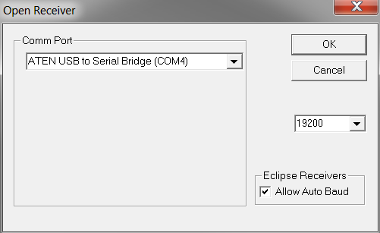

|  |  |
| --- | --- |
| **RightArm**  **Updates**, continued | Choose the COM port connected to the V500 and click **OK**.  **Note:** The baud rate of the serial port should be set to 19200 bps. Select **Allow Auto Baud** to change the baud rate during the firmware upgrade for a faster update. |

*Continued on next page*

|  |  |
| --- | --- |
| **RightArm**  **Updates**, continued | Click the **Programming** button.    Select a **Program Type**.  The V500 has two firmware applications, allowing two different versions of GNSS firmware. Hemisphere GNSS suggests loading the new firmware onto both applications.  After the firmware update is completed, check the current GNSS firmware.  If the current firmware is not the same as the newly loaded firmware, the V500 could be using the other application. You can switch applications by sending the following command:  $JAPP,OTHER.  Choose the Application, and press **Select File** to select the firmware file. |

*Continued on next page*

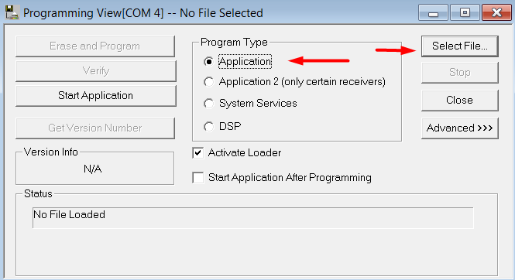

|  |  |
| --- | --- |
| **RightArm**  **Updates**, continued | Choose the firmware, and click **Erase and Program**.  The **Activate Loader** checkbox in the Programming View window is selected. After pressing the Erase and Program button, this checkbox will de-select, and the **Status** field indicates the receiver is in loader mode (ready to receive the new firmware file). |

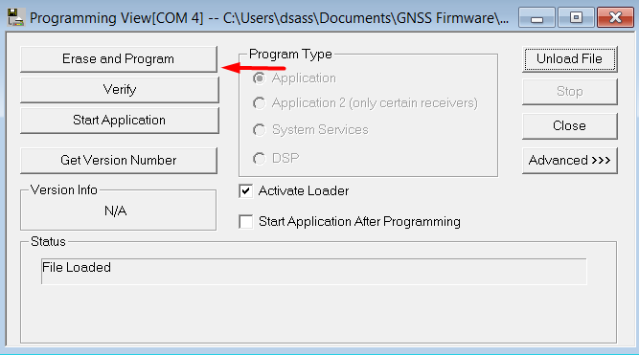

*Continued on next page*



|  |  |
| --- | --- |
| **RightArm Updates**, continued | **Note:** If the Activate Loader check box remains selected, power the receiver off and on. When the receiver powers back on, the Activate Loader box should be de-selected.  **Do not to interrupt the power supply to the receiver, and do not interrupt the communication link between the PC and the receiver until programming is complete. Failure to do so may cause the receiver to become inoperable and will require factory repair.**    **Note:** After completing the firmware update, Hemisphere GNSS suggests repeating this process for the other application. |

## Overview

# Chapter 2: Installing the V500

|  |  |
| --- | --- |
| **Introduction** | This chapter provides instructions on how to mount and install your V500  receiver. |

**Contents**

|  |  |
| --- | --- |
| **Topic** | **See Page** |
| Mounting the V500 | 21 |
| Ports | 32 |
| Selecting Baud Rates and Message Types | 34 |
| Connecting the V500 to External Devices | 34 |

## Mounting the V500

|  |  |
| --- | --- |
| **Introduction** | This section provides information on mounting the V500 in the optimal  location, orientation considerations, environmental considerations, and other mounting options. |

|  |  |
| --- | --- |
| **GNSS satellite**  **reception** | When considering where to mount the V500, consider the following  satellite reception recommendations:   * Ensure there is a clear view of the sky available to the V500 so the GNSS and L-band satellites are not masked by obstructions that may reduce system performance * Mount the V500 in a position in respect to the primary GNSS antenna (located on the end opposite the recessed arrow on the underside of the enclosure) * Locate any transmitting antennas away from the V500 by at least a few meters to ensure tracking performance is not compromised * Ensure cable length is adequate to route into the machine to reach a breakout box or terminal strip * Do not locate the antenna where environmental conditions exceed those specified in Appendix B, Technical Specifications of this document.   A picture containing case, accessory, belt  Description automatically generated  **Figure 2-1: Recessed arrow** |

*Continued on next page*

|  |  |
| --- | --- |
| **Environmental**  **considerations** | Hemisphere Vector Smart Antennas are designed to withstand harsh  environmental conditions; however, adhere to the following limits when storing and using the V500:   * Operating temperature: -40°C to +70°C (-40°F to +158°F) * Storage temperature: -40°C to +85°C (-40°F to +185°F) * Humidity: IEC 16750-4:2010 Section 5.6 Humid heat, cyclic test |

|  |  |
| --- | --- |
| **Mounting**  **orientation** | The V500 outputs heading, pitch, and roll readings regardless of the  orientation of the antennas. The relation of the antennas to the machine’s axis determines if you need to enter a heading, pitch, or roll bias.  The primary antenna is used for positioning and the primary and secondary antennas, working in conjunction, output heading, pitch, and roll values. |

|  |  |
| --- | --- |
| **Parallel**  **orientation** | Parallel installation orients the V500 parallel to, and along the centerline of,  the axis of the machine. **This provides a true heading**. In this orientation:   * If you use a gyrocompass and there is a need to align the Vector smart antenna, you can enter a heading bias in the V500 to calibrate the physical heading to the true heading of the machine. * You may need to adjust the pitch/roll output to calibrate the measurement if the Vector is not installed in a horizontal plane. |

|  |  |
| --- | --- |
| **Perpendicular**  **orientation** | You can also install the antennas so they are oriented perpendicular to the  centerline of the machine’s axis. In this orientation:   * Enter a heading bias of +90° if the primary antenna is on the right side of the machine and -90° if the primary antenna is on the left side of the machine. * Configure the receiver to specify the GNSS smart antenna is measuring the roll axis using the V500 WebUI. * Enter a roll bias to properly output the pitch and roll values. * You may need to adjust the pitch/roll output to calibrate the measurement if the Vector is not installed in a horizontal plane. |

*Continued on next page*

|  |  |
| --- | --- |
| **Mounting**  **orientation example** | **Figure 2-2: Recommended orientation and resulting signs of HPR values** |

*Continued on next page*

|  |  |
| --- | --- |
| **Mounting**  **orientation example,** continued | **Figure 2-3: Alternate orientation and resulting signs of HPR values** |

*Continued on next page*

|  |  |
| --- | --- |
| **Mounting**  **alignment** | The top of the V500 enclosure incorporates sight design features to help  you align the enclosure on your machine.  To use the sights, center the small post on the opposite side of the enclosure from you, within the channel made in the medallion located in the center of the enclosure top as shown in Figure 2-4 and Figure 2-5.  The long sight alignment accuracy (Figure 2-4) is approximately +/- 1°. Short sight alignment accuracy (Figure 2-5) is approximately +/- 2.5°. |

|  |  |
| --- | --- |
| **Mounting**  **options** | The V500 allows for two different mounting options: flush-mount and pole-  mount.   1. **Flush-mount**-The bottom of the V500 contains eight M8-1.25 holes for flush mounting the unit to a flat surface (see Figure 2-5). The eight holes comprise two sets of four holes. Flush mounting does not provide any additional dampening to the receiver. The V500 can be mounted using an optional mounting bracket. See Table 1-1 for bracket part information. 2. **Pole-mount-**The V500 can be mounted using a mounting pole.   **Note:** Hemisphere GNSS does not supply mounting surface hardware or a  mounting pole. You must supply the appropriate mounting hardware required to complete V500 installation. |

*Continued on next page*

|  |  |
| --- | --- |
| **V500**  **dimensions** | Figure 2-4 illustrates the physical dimensions of the V500. |

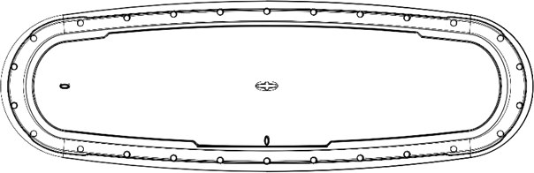

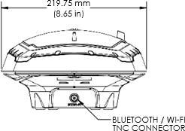

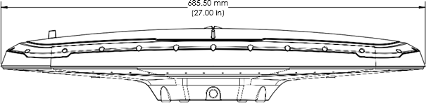

*Continued on next page*

#### V500

**dimensions**, continued

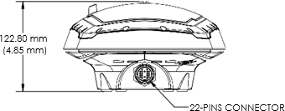

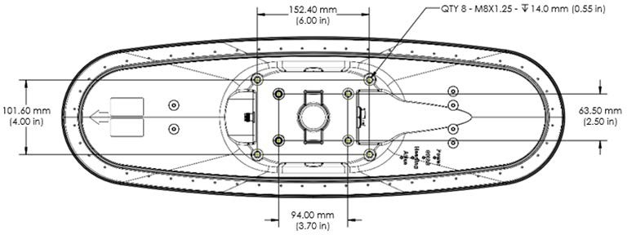

**Figure 2-4: V500 Physical dimensions drawing**

*Continued on next page*

**Power/Data cable considerations**

|  |  |
| --- | --- |
| **Connecting the**  **Serial Power/Data cable** | 1. Align the cable connector key-way with the V500 connector key. 2. Rotate the cable ring clockwise until it locks. The locking action is firm; you will feel a positive “click” when it has locked. 3. Attach the power/data cable to the cable clamp. 4. Fasten the clamp to the bottom of the V500 using the screw and washer. |

Before mounting the V500, consider the following regarding power/data cable routing:

|  |  |
| --- | --- |
| **Do** | **Do not** |
| Ensure cable reaches appropriate  power source | Run cables in areas of excessive  heat |
| Keep cable away from corrosive  chemicals | Run cables through a door or  window jams |
| Connect to a data storage device, computer, or other device that  accepts GNSS data | Crimp or excessively bend the cable |
| Keep cable away from rotating  machinery | Place tension on the cable |
| Remove unwanted slack from the  cable at the V500 end |  |
| Secure along the cable route using  plastic wrapping |



**Improperly installed cable near machinery can be dangerous.**

*Continued on next page*

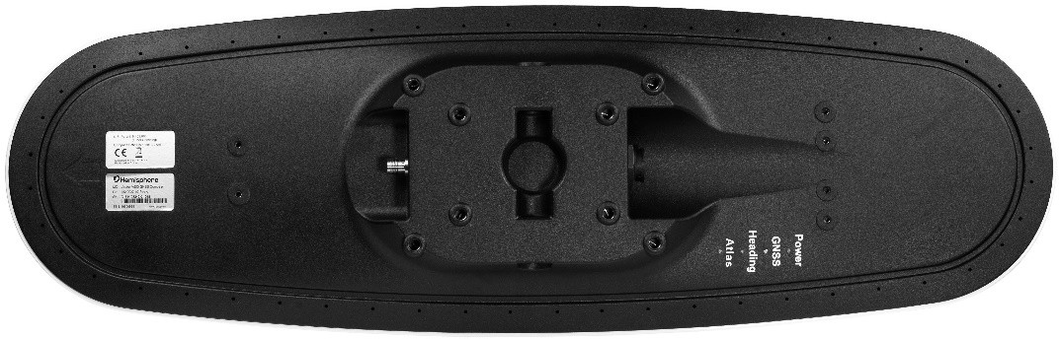

|  |  |
| --- | --- |
| **Flush-mounting**  **the V500** | The bottom of the V500 contains eight holes (two sets of four holes) for  flush-mounting the unit to a flat surface (Figure 2-5).  **Figure 2-5: Flush-mounting holes on bottom of V500** |

*Continued on next page*

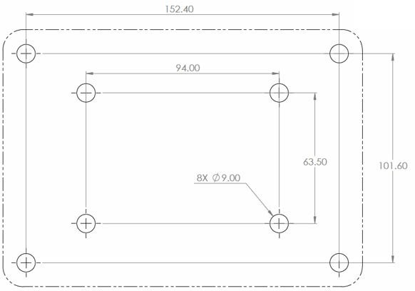

|  |  |
| --- | --- |
| **Assembly**  **drawing** | Figure 2-6 shows the V500 assembly.  **Figure 2-6: Assembly drawing** |

*Continued on next page*

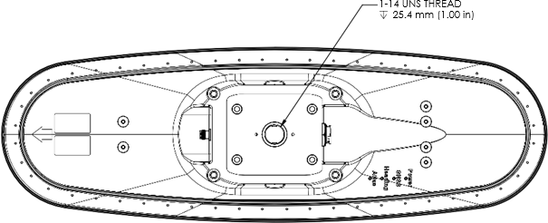

|  |  |
| --- | --- |
| **Pole-mounting**  **the V500** | Figure 2-7 shows the specifications for pole-mounting the V500 antenna.    **Figure 2-7: Pole-mounting specifications** |

*Continued on next page*

|  |  |
| --- | --- |
| **Overview** | The V500 offers serial port, CAN, and Ethernet port functionality. |

|  |  |
| --- | --- |
| **Serial ports** | The V500 has two serial ports:   * Port A can be both full-duplex RS-232 and half-duplex RS-422 (transmit only) * Port B is full-duplex RS-232 or RS-422 (default)   Use the WebUI or one of the following commands ($JRELAY,PORTC,$JPORTB,RS232 or $JRELAY,PORTC,$JPORTB,RS422) to  switch Port B between RS-232 and RS-422.  You can receive external differential corrections via either Port A (full- duplex RS-232) or Port B (full-duplex RS-232 or full-duplex RS-422). You can connect up to three devices at one time using two ports.  One device can receive data via Port A (RS-422 transmit only) while two devices can transmit and receive data via Ports A and B (one connected to Port A RS-232 and one connected to Port B).  You can update firmware via Port A (RS-232) or Port B. |
|  | **Note:** The V500 has maximum baud rate of 115200. |

*Continued on next page*



**Ports,** Continued

|  |  |
| --- | --- |
| **Serial port**  **configuration** | You may configure Port A or Port B of the GNSS receiver to output any  combination of data.  Port A can have a different configuration from Port B in data message output, data rates, and the baud rate of the port, and configure the ports independently based upon your needs. Both RS-232 and RS-422 output signals may be used simultaneously.  The RS-232 Port A and RS-422 Port A output the same data messages at the same baud rate. If the baud rate or messages for the RS-422 port need to be changed, this needs to be commanded through the RS-232 port.  **Note:** For successful communications, use the 8-N-1 protocol and set the baud rate of the V500’s serial ports to match that of the devices to which they are connected. Flow control is not supported. |

|  |  |
| --- | --- |
| **Baud Rates &**  **Message Types** | When selecting your baud rate and message types, use the following  formula to calculate the bits/sec for each message and sum the results to determine the baud rate for your required data throughput.  Message output rate * Message length (bytes) * bits in byte = Bits/second (1 character = 1 byte, 8 bits = 1 byte, use 10 bits/byte to account for overhead).  For information on message output rates refer to the [Hemisphere GNSS](https://hemispheregnss.com/Resources-Support/Technical-Documentation) [Technical Reference Manual](https://hemispheregnss.com/Resources-Support/Technical-Documentation). |

## Connecting the V500 to External Devices

|  |  |
| --- | --- |
| **Recommend-**  **ations for connecting to other devices** | When interfacing to other devices, ensure the transmit data output and the  signal grounds from the V500 is connected to the data input of the other device.  The RS-422 is a balanced signal with positive and negative signals referenced to ground; ensure you maintain the correct polarity.  When connecting the transmit data output positive signal to the receive line of the other device, it should be connected to the receive positive terminal.  The negative transmit data signal from the V500 is then connected to the receive data negative input of the other device.  For a list of Hemisphere GNSS commands, please refer to the [Hemisphere](https://hemispheregnss.com/Resources-Support/Technical-Documentation) [GNSS Technical Reference Manual](https://hemispheregnss.com/Resources-Support/Technical-Documentation). To configure the unit through the WebUI, please refer to Configuring the V500 using WebUI. |

*Continued on next page*

|  |  |
| --- | --- |
| **Power/Data**  **cable considerations** | The V500 uses a single 3m, or 15m (optional) cable for power and data  input/ output.  The receiver end of the cable is terminated with an environmentally-sealed 22-Pin connection while the opposite end is unterminated and requires field stripping and tinning.  Depending on the application and installation needs, you may need to shorten this cable. However, if you require a longer cable run than 15m, you can bring the cable into a break-out box that incorporates terminal strips, within the machine.  When lengthening the cable keep the following in mind:   * To lengthen the serial lines inside the machine, use 20-gauge twisted pairs and minimize the additional wire length. * When lengthening the power input leads to the V500, ensure the additional voltage drop is small enough that your power system can continue to power the system above the minimum voltage of the system. Wire of 18-gauge or larger should also be used. * Minimize RS-232 cable length to ensure reliable communication. |

*Continued on next page*

|  |  |
| --- | --- |
| **V500 with 22 to**  **18 pins adapter** | Use the 22-Pin to 18-Pin adapter if you want to use a V320 cable.  **Note:** Using the adapter will cause you to lose ethernet capability.        **Figure 2-8: V500 with 22-Pin to 18-Pin adapter** |

*Continued on next page*

|  |  |
| --- | --- |
| **Power/data**  **cable pin-out assignments** | Figure 2-9 shows the power/data cable pin-out assignments.    **Figure 2-9: V500 pin-out assignments** |

*Continued on next page*

**Power/data cable pin-out specifications**

Table 2-1 shows the cable pin-out specifications.

**Table 2-1: V500 pin-out specifications**

|  |  |  |
| --- | --- | --- |
| **Pin** | **Function** | **Color** |
| 1 | Power + | Red |
| 2 | CAN1 High | Orange-Black stripe |
| 3 | CAN1 Low | Yellow Black stripe |
| 4 | Port B RS-232 RX/RS-422 A | Orange |
| 5 | Port B RS-232 TX/RS-422 Z | Yellow |
| 6 | CAN2 High | Green |
| 7 | CAN2 Low | Blue |
| 8 | Port B RS-422 B | Purple |
| 9 | Port B RS-422 Y | Grey |
| 10 | 1PPS Output | White |
| 11 | Port A RS-232 RX | Pink |
| 12 | Port A RS-232 TX | Turquoise |
| 13 | Signal Ground | Black-White stripe |
| 14 | Ethernet TD+ | Brown-White stripe |
| 15 | Ethernet TD- | Red-White stripe |
| 16 | Heading Warning | Orange-White stripe |
| 17 | Speed Output | Green-White stripe |
| 18 | Ethernet RD+ | Blue-White stripe |
| 19 | Ethernet RD- | Purple-White stripe |
| 20 | Manual Mark Input | Red-Black stripe |
| 21 | Power + | Brown |
| 22 | Power - | Black |

## Overview

# Chapter 3: Understanding the V500

|  |  |
| --- | --- |
| **Introduction** | The GNSS receiver begins tracking satellites when it powers up and an  antenna has connected to the antenna port on the receiver. Position and heading accuracy vary depending upon location and environment. Position performance can be improved with RTK or DGNSS.  The following sections provide the steps to configure your V500 to use Atlas, SBAS, or RTK.  **Note:** Differential source and RTK status impact only positioning and heave. There is no impact to heading, pitch, or roll. |

**Contents**

|  |  |
| --- | --- |
| **Topic** | **See Page** |
| Differential and RTK Operation | 40 |
| SBAS Tracking | 40 |
| Athena RTK | 41 |
| Atlas L-band | 42 |
| Supported Constellations | 42 |
| Supplemental Sensors | 43 |
| Time Constants | 45 |

**Differential and RTK Operation**

|  |  |
| --- | --- |
| **Differential**  **(DGNSS) and RTK operation** | The purpose of differential GNSS (DGNSS) and RTK is to remove the effects  of atmospheric errors, timing errors and satellite orbit errors, while enhancing system integrity.  Autonomous positioning capabilities of the V500 will result in positioning accuracies of 2.5m 95% of the time.  To improve positioning quality, the V500 can receive DGNSS corrections over SBAS, L-band corrections with Hemisphere GNSS’ Atlas L-band technology, or RTK corrections over serial.  For more information on the differential services and the associated commands refer to the [Hemisphere GNSS Technical Reference](https://hemispheregnss.com/Resources-Support/Technical-Documentation) Manual. |

**SBAS Tracking**

|  |  |
| --- | --- |
| **SBAS tracking** | SBAS is a standard feature on the V500 and does not require an activation  or subscription code.  The V500 automatically scans and tracks SBAS signals without the need to tune the receiver.  The V500 features two-channel tracking that provides an enhanced ability to maintain a lock on an SBAS satellite when more than one satellite is in view.  This redundant tracking approach results in more consistent tracking of an SBAS signal in areas where signal blockage of a satellite is possible.  **Note:** The V500 moving base station algorithm uses only GNSS to calculate heading. Differential and RTK corrections are not used in this calculation and will not affect heading accuracy. |

|  |  |
| --- | --- |
| **Athena RTK** | Athena RTK requires the use of two separate receivers: a stationary base  station (primary receiver) that broadcasts corrections over a wireless link to the rover (secondary receiver).  The V500 can use RTK through either serial port. The receiver uses any RTK message coming in over a serial port if the RTK message type is included in the list of available differential sources.  If you do not know which RTK message type is being sent by the base station, you can include RTCM3, ROX, and CMR.  Including extra differential sources will not affect the receiver if those differential sources are not being received.  After setting the differential source configure the baud rate of the serial port receiving the RTK corrections. Ensure that the serial port configuration of the external device (such as modem) is 8 bits/byte, 1 stop bit, no parity and no flow control.  Connect the external device to the serial port of the V500. Some cables may require the use of a gender changer and/or null modem adapter. |

|  |  |
| --- | --- |
| **Atlas L-band** | Atlas L-band corrections are available worldwide. With Atlas, the  positioning accuracy does not degrade as a function of distance to a base station, as the data content is not composed of a single base station’s information, but an entire network’s information.  The V500 can calculate a position with 4 cm RMS (horizontal) accuracy in an industry-leading time of 20 minutes.  To configure the receiver to use Atlas L-band, a subscription must be purchased. |

**Supported Constellations**

|  |  |
| --- | --- |
| **GLONASS,**  **Galileo & BeiDou** | V500 is available in its base form as L1 GPS, G1 GLONASS, E1 Galileo, and B1  BeiDou.  By adding multi-frequency GPS, GLONASS, Galileo, and BeiDou, the number of available signals increases, improving the ability to obtain and maintain a heading solution.  For a heading calculation, GPS, GLONASS, Galileo and BeiDou satellites are used interchangeably, as intersystem biases cancel inside the V500—this translates into being able to work in more obstructed areas and maintain a  GNSS heading solution. |

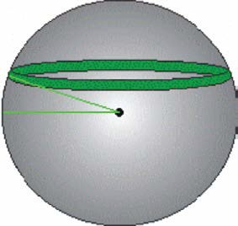

|  |  |
| --- | --- |
| **Overview** | The V500 has an integrated gyro and two tilt sensors, which are enabled by  default. Each supplemental sensor may be individually enabled or disabled. Both supplemental sensors are mounted on the printed circuit board inside the V500.  The sensors act to reduce the RTK search volume, which improves heading startup and reacquisition times. This improves the reliability and accuracy of selecting the correct heading solution by eliminating other possible, erroneous solutions.  The [Hemisphere GNSS Technical Reference Manual](https://hemispheregnss.com/Resources-Support/Technical-Documentation) describes the commands and methodology required to recalibrate, query, or change the sensor status. |

|  |  |
| --- | --- |
| **Tilt Aiding** | The V500’s accelerometers (internal tilt sensors) are factory calibrated and  enabled by default and constrains the RTK heading solution beyond the volume associated with a fixed antenna separation.  The V500 knows the approximate inclination of the secondary antenna with respect to the primary antenna. The search space defined by the tilt sensor is reduced to a horizontal ring on the sphere’s surface by reducing the search volume and decreases startup and reacquisition times (see Figure 3- 1).  Tilt angle  **Figure 3-1: V500 tilt aiding** |

*Continued on next page*

|  |  |
| --- | --- |
| **Gyro aiding** | The V500’s internal gyro reduces the sensor volume for an RTK solution and  shortens reacquisition times when a GNSS heading is lost due to blocked satellite signals.  The gyro provides a relative change in angle since the last computed heading, and, when used in conjunction with the tilt sensor, defines the search space as a wedge-shaped location (see Figure 3-2).    **Figure 3-2: V500 gyro aiding**  The gyro aiding accurately smooths the heading output and the rate of turn, and provides an accurate substitute heading for a short period depending on the roll and pitch of the machine (ideally seeing the system through to reacquisition).  The gyro provides an alternate source of heading, accurate to within 1º per minute for up to three minutes, in times of GNSS loss for either antenna. If the outage lasts longer than three minutes, the gyro will have drifted too far and the V500 begins outputting null fields in the heading output messages. There is no user control over the timeout period of the gyro.  The gyro initializes itself at power up and during initialization, or you can calibrate it as outlined in the [Hemisphere GNSS Technical Reference](https://hemispheregnss.com/Resources-Support/Technical-Documentation) [Manual](https://hemispheregnss.com/Resources-Support/Technical-Documentation).  For optimal performance, when the gyro is first initializing, the dynamics the gyro experiences during this warm-up period are similar to the regular operating dynamics. |

*Continued on next page*

|  |  |
| --- | --- |
| **Gyro aiding**,  continued | With the gyro enabled, it is used to update the post HTAU smoothed  heading output from the moving base station RTK GNSS heading computation.  If the HTAU value is increased while gyro aiding is enabled, there will be little to no lag in heading output due to vehicle manoeuvres.  The [Hemisphere GNSS Technical Reference Manual](https://hemispheregnss.com/Resources-Support/Technical-Documentation) includes information on setting an appropriate HTAU value for the application. |

## Time Constants

|  |  |
| --- | --- |
| **Overview** | The V500 incorporates user-configurable time constants that can provide a  degree of smoothing to the heading, pitch, Rate-of-Turn (ROT), Course- over-Ground (COG), and speed measurements.  You can adjust these parameters depending on the expected dynamics of the machine. For example, increasing the time is reasonable if the machine is very large and is not able to turn quickly or would not pitch quickly. The resulting values would have reduced “noise,” resulting in consistent values with time. If the machine is quick and nimble, increasing this value can create a lag in measurements.  Formulas for determining the level of smoothing are located in the [Hemisphere GNSS Technical Reference Manual](https://hemispheregnss.com/Resources-Support/Technical-Documentation). If you are unsure how to set this value, it is best to be conservative and leave it at the default setting. |

*Continued on next page*

|  |  |
| --- | --- |
| **Heading** | Use the $JATT,HTAU command to adjust the level of responsiveness of the  true heading measurement provided in the $GPHDT message. The default value of this constant is 0.1 seconds of smoothing when the gyro is enabled. The gyro is enabled by default but can be disabled.  By disabling the gyro, the equivalent default value of the heading time constant would be 0.5 seconds of smoothing. This is not automatic, and therefore it must be manually entered.  Increasing the time constant increases, the level of heading smoothing and increases lag. |

|  |  |
| --- | --- |
| **Pitch** | Use the $JATT,PTAU command to adjust the level of responsiveness of the  pitch measurement provided in the $PSAT,HPR message. The default value of this constant is 0.5 seconds of smoothing.  Increasing the time constant increases the level of pitch smoothing and increases lag. |

|  |  |
| --- | --- |
| **Rate-of-Turn**  **(ROT)** | Use the $JATT,HRTAU command to adjust the level of responsiveness of the  ROT measurement provided in the $GPROT message. The default value of this constant is 2.0 seconds of smoothing.  Increasing the time constant increases the level of ROT smoothing. |

*Continued on next page*

|  |  |
| --- | --- |
| **Course-Over-**  **Ground (COG)** | Use the $JATT,COGTAU command to adjust the level of responsiveness of  the COG measurement provided in the $GPVTG message. The default value of this constant is 0.0 seconds of smoothing.  Increasing the time constant increases the level of COG smoothing.  COG is computed using only the primary GNSS antenna and its accuracy depends upon the speed of the machine (noise is proportional to 1/speed).  This value is invalid when the machine is stationary. |

|  |  |
| --- | --- |
| **Speed** | Use the $JATT,SPDTAU command to adjust the level of responsiveness of  the speed measurement provided in the $GPVTG message. The default value of this parameter is 0.0 seconds of smoothing.  Increasing the time constant increases the level of speed measurement smoothing. |

## Overview

# Chapter 4: Operating the V500

|  |  |
| --- | --- |
| **Introduction** | The chapter includes information about powering and configuring your  V500 receiver. |

**Contents**

|  |  |
| --- | --- |
| **Topic** | **See Page** |
| Powering the Receiver On/Off | 49 |
| LED Indicators | 50 |
| Configuring the V500 Using the WebUI | 51 |



## Powering the Receiver On/Off

|  |  |
| --- | --- |
| **Power the**  **receiver on/off** | To power on the V500, connect the ends of the V500 power cable to a clean  power source providing 9 to 32 VDC, and hold the soft power switch until the screen illuminates.  The V500 accepts an input voltage of 9 to 32 VDC via the power cable. The supplied power should be continuous and clean for best performance.  Refer to Appendix B for the power specifications of the V500.  **Do not apply a voltage higher than 32 VDC. This will damage the receiver and void the warranty. A 3 Amp power fuse is recommended for the protection of personnel and the system.**  The V500 features reverse polarity protection to prevent damage if the power leads are accidentally reversed. Although the V500 proceeds through an internal startup sequence when you apply power, it will be ready to communicate immediately.  Initial startup may take 5 to 15 minutes depending on the location. Subsequent startups will output a valid position within 1 to 5 minutes depending on the location and time since the last startup.  The V500 may take up to 5 minutes to receive a full ionospheric map from SBAS. Optimum accuracy is obtained once the V500 is processing corrected positions using complete ionospheric information.  **Note:** Hemisphere GNSS recommends using a weather-tight connection and connector if the connection is located outside. |

**Overview** The V500 has four LED lights located bottom of the unit. Table 4-1 below describes each LED indicator.

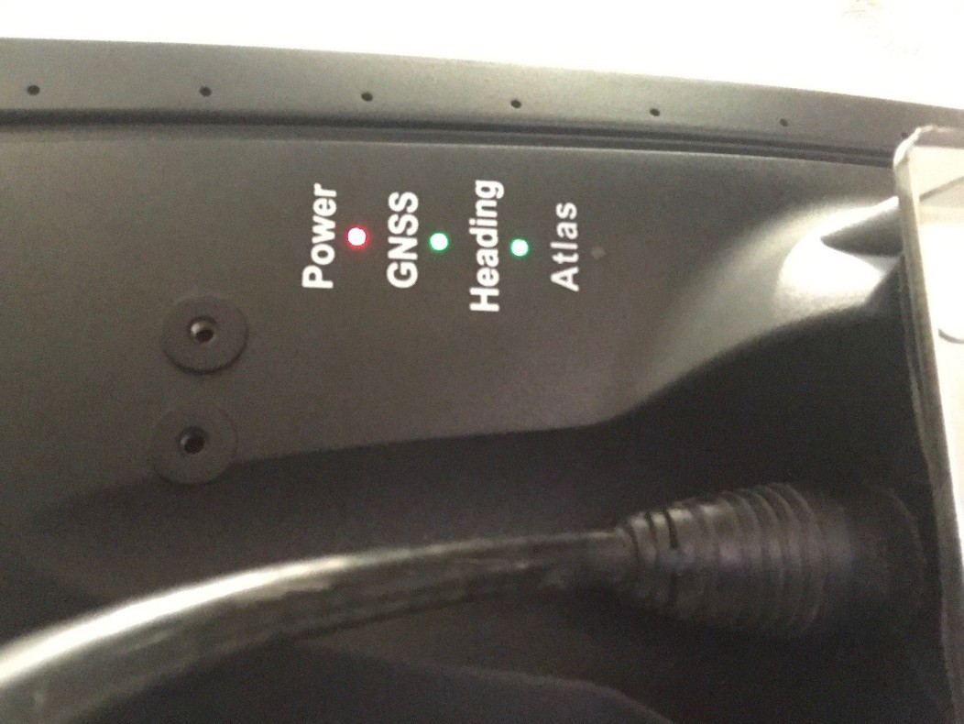

### Figure 4-1: V500 LED Display Table 4-1: LED indicators

|  |  |
| --- | --- |
| **Indicator** | **Description/Function** |
| Power | Solid red indicates receiver is powered on |
| GNSS | Solid green indicates RTK fixed Flashing green indicates DGPS/Float |
| Heading | Solid green indicates 2D GNSS heading  Solid red indicates 2D sensor heading |
| Atlas | Solid green indicates Atlas locked  Solid red indicates Atlas activated, but not locked |

|  |  |
| --- | --- |
| **Overview** | The V500 is equipped with an onboard WebUI.  First, connect the Bluetooth/WiFi antenna to the connector. The receiver displays as an available Wi-Fi device in your available networks. Connect the tablet or PC to the V500’s WiFi.  To log in use the password: hgnss1234  Open a web browser window and type the following IP address: 192.168.100.1  The V500 Main Menu displays. |

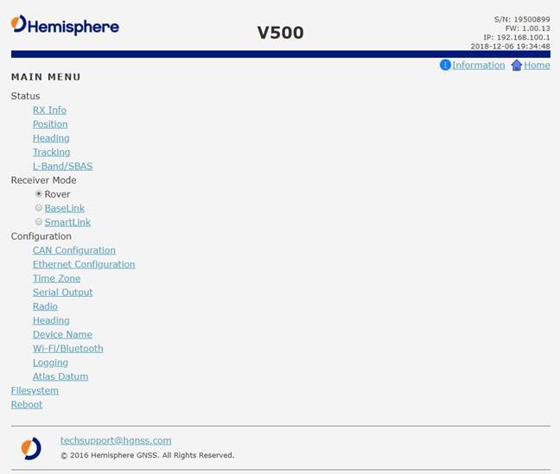

*Continued on next page*

**Status** You can configure RX Info, Position, Heading, Tracking, L-band and SBAS.

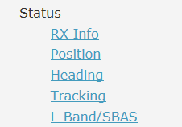

### Table 4-2: Status links

|  |  |
| --- | --- |
| **Link** | **Description** |
| RX Info | Serial number of the board, firmware versions, and  subscriptions |
| Position | Position, accuracy, HDOP, number of satellites used, and  differential/RTK status |
| Heading | Heading, COG, the offset between heading and COG,  ROT, yaw, pitch, roll, heave and speed |
| Tracking | Sky plot and SNRs of signals tracked |
| L-band/SBAS | Manually tune the antenna to track a specific L-band satellite or to set the receiver up to automatically select  the correct SBAS satellite |

*Continued on next page*

|  |  |
| --- | --- |
| **RX info** | The Serial Number, Board Type, Carrier Firmware (for both GNSS and carrier  board), Carrier Uptime, WiFi MAC Address, and your Subscriptions are displayed.  Activated items have a green check mark.  **Important:** If you have purchased an activation or subscription, use the field at the bottom of the screen to type the Subscription Code, and click ***Confirm***. |

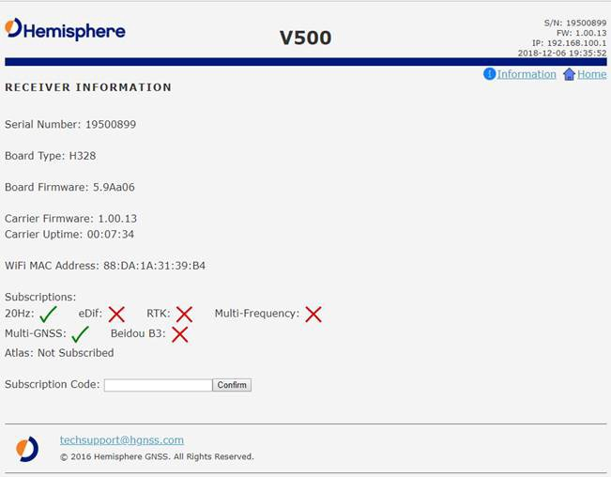

*Continued on next page*

|  |  |
| --- | --- |
| **Position** | Position and time are displayed at the top of the screen. In the example  below, the Time Zone is set to UTC-10, Honolulu time.  To change the Time Zone, go to the main page and click **Time Zone**. Please note this does not affect UTC time in NMEA output.  An estimate of your 3D (and 2D) position accuracy is given in both RMS and 2DRMS.  **HDOP-**Horizontal Dilution of Precision  **Satellites Used-**Number of satellites used  **Solution Type-**Fixed, Float, etc. **Differential Source-**Atlas, RTK, etc. **Age of Differential-**RTK latency |

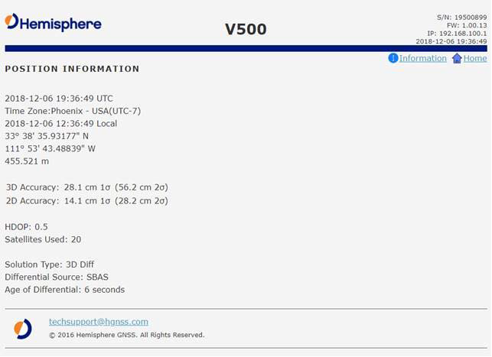

*Continued on next page*

**Heading** The **Heading Information** screen displays the following data:

|  |  |
| --- | --- |
| **Term** | **Definition** |
| Compass rose | the difference between heading and COG |
| Heading | the direction of the vector created from the primary to secondary antenna. Heading is measured using true north |
| COG | the direction the machine is moving |
| YAW | the difference between COG and heading |
| Pitch | angle between the front and back of the machine |
| Roll | angle between the left and right side of the  machine |
| Heave | the upward movement of the ground |
| Speed | speed of machine in km/h |

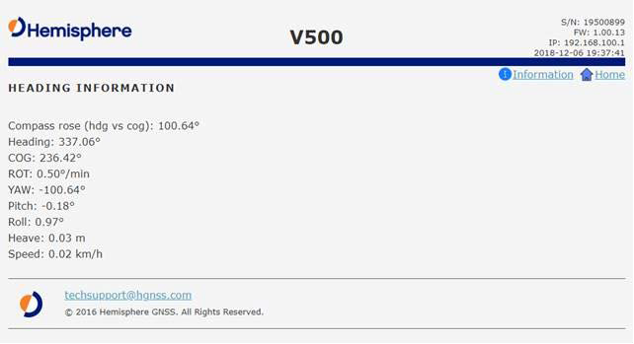

*Continued on next page*

|  |  |
| --- | --- |
| **Tracking** | The Sky Plot shows the elevation, azimuth, and SNR values of all tracked  satellites. |

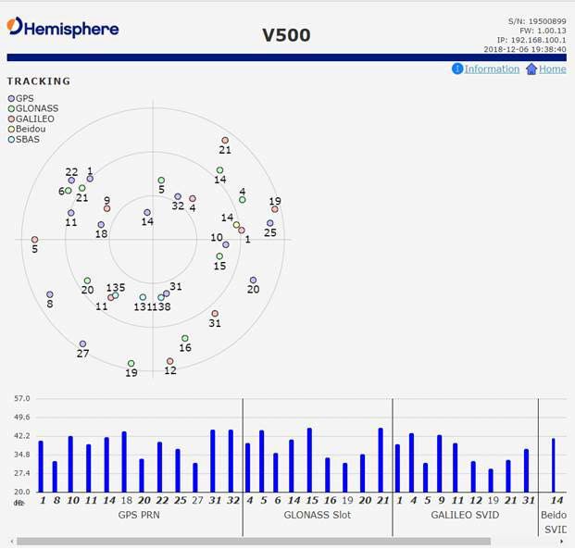

*Continued on next page*

|  |  |
| --- | --- |
| **L-band/SBAS** | You can manually configure the frequency and bandwidth of the L-band  satellite you wish to track, or simply click the **Auto** button and let the receiver track automatically. |

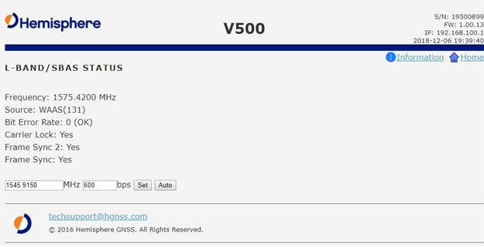

**Receiver mode overview**

Use the **Receiver Mode** menu to configure the V500 as a standard GNSS receiver, or as a SmartLink receiver.

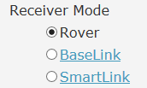

### Table 4-3: Receiver mode

|  |  |
| --- | --- |
| **Link** | **Description** |
| Rover | Configure the V500 as a standard GNSS receiver |
| SmartLink | Uses Atlas as a correction source and outputs the correction over serial as a standard RTCM3 message |

*Continued on next page*

|  |  |
| --- | --- |
| **Rover** | If you are using this as a Rover receiver, select **Rover Receiver Mode.** To  use in the **SmartLink** receiver mode, select **Change Mode** and select the appropriate mode. |

|  |  |
| --- | --- |
| **SmartLink** | SmartLink allows the V500 to use Atlas as a correction source and then  output the correction over serial as a standard RTCM 3 message.  Click the **SmartLink** hyperlink. Configure the RTCM3 format (such as MSM4) using the **Correction Output** dropdown menu.  Set the baud rate of the serial port that will output the correction. Set a target accuracy. Once the Atlas solution has converged to below this threshold, RTCM3 messages begin to output over the serial port. |

*Continued on next page*

|  |  |
| --- | --- |
| **Configuration**  **overview** | You can configure the following using the V500 WebUI:   * CANbus * Ethernet * Time zone * Serial port baud rate and output * Heading constants * Device name * WiFi Bluetooth settings * Logging options * Data (used by Atlas corrections) |

|  |  |
| --- | --- |
| **CAN** | Turn ON/OFF CAN and select the baud rate (250 kbps or 500 kbps). |

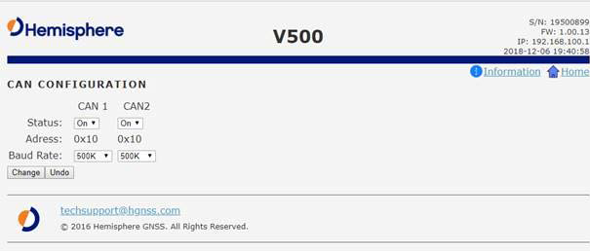

*Continued on next page*

|  |  |
| --- | --- |
| **Ethernet** | Use the V500 WebUI to configure the Ethernet connection. |

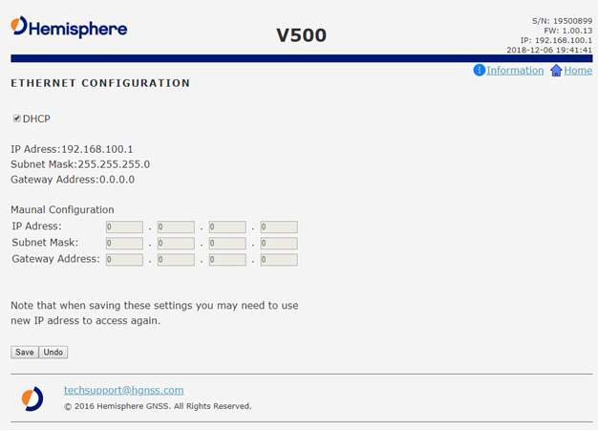

*Continued on next page*

|  |  |
| --- | --- |
| **Serial Output** | Use Serial Output to configure the baud rate of each serial port (PortA and  PortB and turn off/on specific NMEA 0183 messages and proprietary Hemisphere BIN messages.  You can also change Port B from RS-232 to RS-422 and RS-422 to RS-232 reciprocally.  Configure the baud rates of the serial ports and click **Change**. |

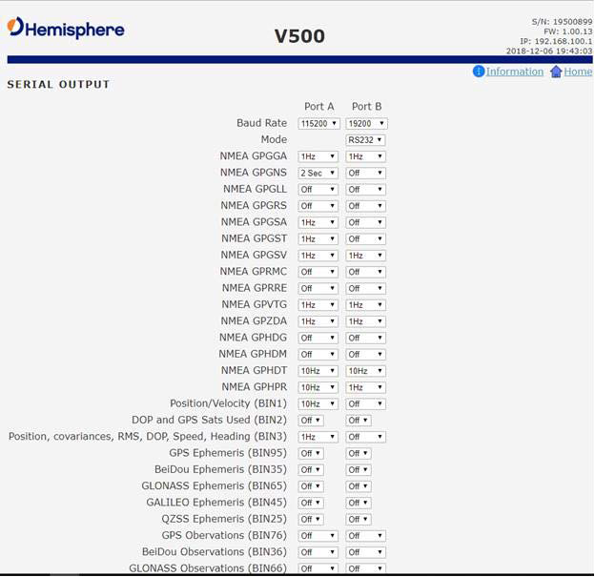

*Continued on next page*

|  |  |
| --- | --- |
| **Heading** | Authorized users may change the Heading configuration.  Under the **Configuration** menu, click **Heading**. If you are an authorized user, type the Hemisphere GNSS provided password, and click **Login**. |

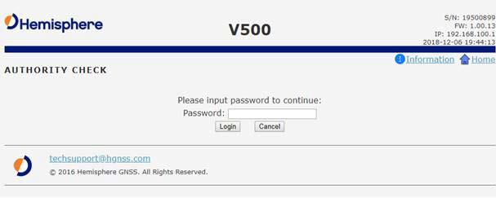

|  |  |
| --- | --- |
| **Heading**, continued | **Note:** Default settings can be changed to set the time constants to smooth heading, Course-over-Ground (COG), and speed measurements. Various heading settings can also be configured.  Click the box of the desired setting and type the configuration setting values. |

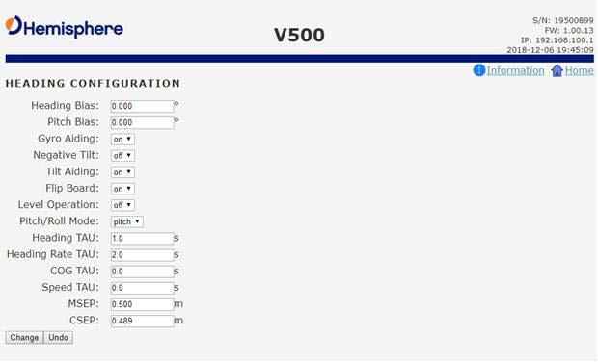

*Continued on next page*

**Heading**, continued

### Table 4-4: Heading configurations

|  |  |  |  |
| --- | --- | --- | --- |
| **Time Constant** | **Description** | | |
| Heading Bias | Add a bias to the heading value the receiver outputs.  Range: -180 – +180 | | |
| Pitch Bias | Add a bias to the pitch value the receiver outputs.  If the receiver is in “roll” mode, this will add a bias to the roll instead.  Range: -15 – +15 | | |
| Gyro Aiding | Gyro aiding enables the use of the internal gyro sensor and allows for the continuous output of heading for up to three minutes during a GNSS outage. Gyro aiding improves the reacquisition time when GNSS heading is lost because of an  obstruction in GNSS signal. | | |
| Negative Tilt | Change the sign of the pitch/roll measurement. | | |
| Tilt Aiding | Turn OFF or ON tilt aiding. When on, the sensors are used to reduce the RTK search volume –  improving heading startup and reacquisition times. | | |
| Flip Board | N/A | | |
| Pitch/Roll Mode | If the antennas are mounted such that they model pitch, set to PITCH.  If the antennas are mounted such that they model roll), set this to ROLL. | | |
|  | **Note:** If your HBIAS is -90 or +90, this will be set to  ROLL. If your HBIAS is 0 or 180, set this to PITCH. |  |

*Continued on next page*

**Heading**, continued

### Table 4-4: Heading configurations (continued)

|  |  |
| --- | --- |
| **Time Constant** | **Description** |
| HTAU  (Heading) | Adjust the responsiveness to true heading.  If the machine is large and unable to turn quickly, increase this value.  For longer baselines (10 m) HTAU should be between 0.1 and 0.5, since the gyro introduces noise.  **Default value:** 0.1 s with gyro enabled Range: 0.0 to 60 s  **Formula:** htau (s) = 40 / max rate of turn (°/s) *with gyro ON* htau (s) = 10 / max rate of turn (°/s) *with*  *gyro OFF* |
| HRTAU  (Rate of Turn) | Adjust the responsiveness to the rate of heading change.  If the machine is large and unable to turn quickly, increase this value.  **Default value:** 2.0 s with gyro enabled Range: 0.0 to 60 s  **Formula:** hrtau (s) = 10 / max rate of the rate of  turn (°/s2) |

*Continued on next page*

**Heading**, continued

### Table 4-4: Heading configurations (continued)

|  |  |  |  |
| --- | --- | --- | --- |
| **Time Constant** | **Description** | | |
| COGTAU  (Course Over Ground) | Adjust the responsiveness to the course over ground measurement.  If the machine is small and dynamic, leave this value at 0.0 s to be conservative.  If the machine is large and resistant to motion, increase this value.  **Default value:** 0.0 s Range: 0.0 to 60 s  **Formula:** cogtau (s) = 10 / max rate of change of course (°/sec) | | |
| SPDTAU  (Speed) | Adjust the responsiveness to speed.  If the machine is small and dynamic, leave this value at 0.0 s to be conservative.  If the machine is large and resistant to motion, increase this value.  **Default value:** 0.0 s Range: 0.0 to 60 s  **Formula:** spdtau (s) = 10 / max acceleration (m/s2) | | |
| CSEP | This is the antenna separation calculated by the receiver. Ensure the CSEP value is within 0.2 of 0.5 (within two cm of 50 cm). | | |
|  | **Note:** If CSEP value is “0” the receiver is unable to calculate the separation between the primary and  secondary antennas. |  |

*Continued on next page*

|  |  |
| --- | --- |
| **Device name** | Change the name of the receiver (displayed at the top of the WebUI). |

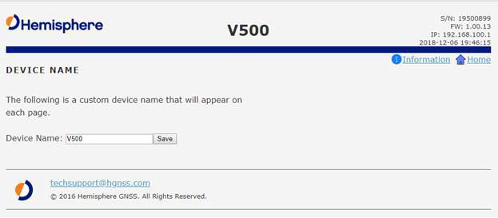

|  |  |
| --- | --- |
| **Wi-Fi Bluetooth**  **configuration** | Configure the WiFi access name, encryption mode, and encryption key of  the V500 in the WiFi/Bluetooth configuration settings. Click to enable Bluetooth options and type the PIN of the V500.  **Note:** The V500 internal filesystem cannot be accessed when Bluetooth is enabled. To access the internal filesystem, disable Bluetooth. |

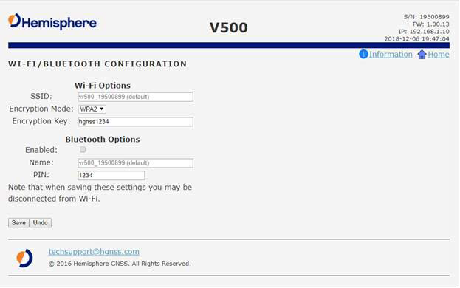

*Continued on next page*

**Logging** Log data to the internal memory of the V500 or download a previously saved log.

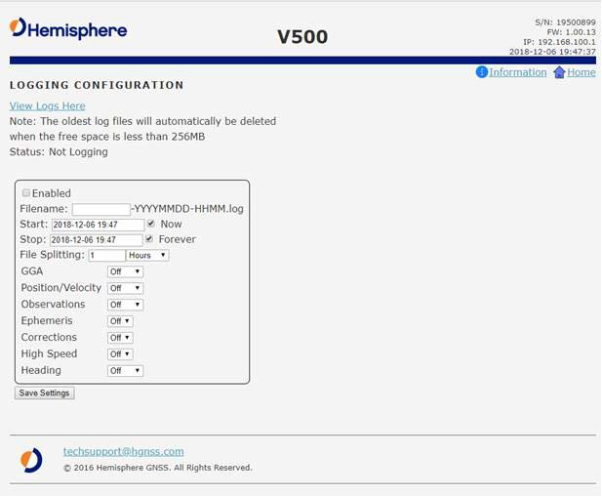

### Table 4-5: Logging configuration

|  |  |
| --- | --- |
| **Field** | **Description** |
| Enabled checkbox | Click to enable logging.  Each time the V500 is powered on, logging begins with the specified settings. |
| Filename | Choose a filename.  All filenames automatically have an appended date and timestamp. |
| Start/Stop | Set a time to start and a time to stop logging. |
| Now/Forever | Select the logs to start logging now, or to log  indefinitely (until shut off). |

*Continued on next page*

**Logging**, continued

### Table 4-5: Logging configuration (continued)

|  |  |  |  |
| --- | --- | --- | --- |
| **Field** | **Description** | | |
| File Splitting | Automatically closes a file and restarts a new file after a period of time.  Use file splitting to decrease file sizes or to prevent the loss of a file resulting in the loss of all data | | |
| GGA | Turn on GGA message logging at 0.2Hz, 1Hz, 10Hz, or 20HZ. | | |
|  | **Note:** 10Hz and 20Hz are only available with  activations (some kits may come with 10Hz or 20Hz included). |  |
| Position Velocity | Log the position and velocity of the receiver at 0.2Hz, 1Hz, 10Hz, or 20HZ. | | |
|  | **Note:** 10Hz and 20Hz are only available with  activations (some kits may come with 10Hz or 20Hz included). |  |
| Observations* | Log raw GNSS observations at 0.2Hz, 1Hz, 10Hz, or 20HZ.  **Note:** 10Hz and 20Hz are only available with activations (some kits may come with 10Hz or 20Hz included).  *This feature is only available if you have a “Raw” activation on the receiver. | | |

*Continued on next page*

**Logging,**

continued

### Table 4-5: Logging configuration (continued)

|  |  |
| --- | --- |
| **Field** | **Description** |
| Ephemeris* | Log raw GNSS ephemeris messages at 0.2Hz, 1Hz, 10Hz, or 20HZ.  **Note:** 10Hz and 20Hz are only available with activations (some kits may come with 10Hz or 20Hz included).  *This feature is only available if you have a “Raw” activation on the receiver. |
| Corrections | Log the correction messages coming into the  receiver. |
| High Speed | High Speed logs diagnostic data.  **Note:** Selecting that dropdown option forces the GGA, “corrections” and “ephemeris” options on. |
| Heading | Heading logs the following messages:   * GPHDT * GPHDM * GPHDG * HPR * BIN3 |

To stop logging, de-select the **Enabled** button and press **Save Settings**.



**If you turn off the receiver without properly closing a log, the log file will become corrupted.**

*Continued on next page*

|  |  |
| --- | --- |
| **Atlas Datum** | If using Atlas (**not RTK**), datum defaults to ITRF08.  You can change Datum Type to GDA94 or enter custom reference frame offsets. |

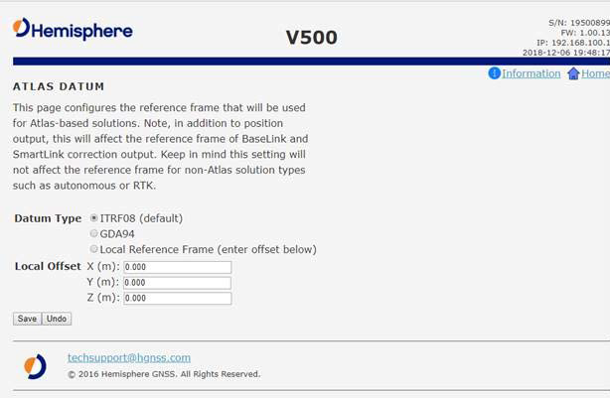

|  |  |
| --- | --- |
| **Filesystem** | The filesystem can be used to download log files that have been previously  stored onto the V500, or the filesystem can be used to upgrade both GNSS firmware or carrier board firmware.  **Note:** The filesystem cannot be used when Bluetooth is enabled. If Bluetooth is enabled, an option will be given to disable Bluetooth. |

*Continued on next page*

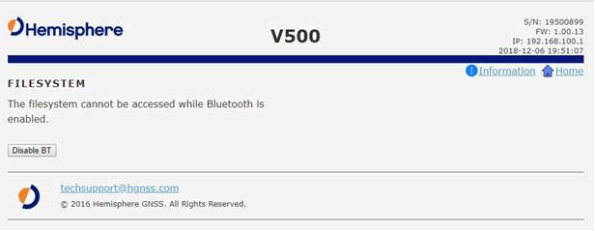

|  |  |
| --- | --- |
| **Filesystem**,  continued | After Bluetooth is disabled, the filesystem displays. Any log files stored on the receiver will be available for download.  To upgrade firmware, click **Choose File**, select the GNSS or carrier board firmware, and press “Upload.” |

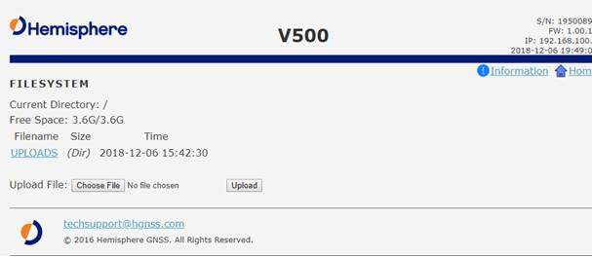

*Continued on next page*

|  |  |
| --- | --- |
| **Filesystem**,  continued | After the file is uploaded, the list of files display.  Click **Load GNSS FW** or **Load Carrier FW**. When the FW is complete, click  **Delete**. |

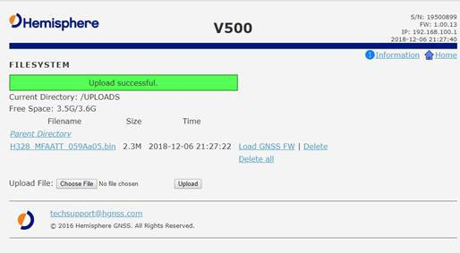

|  |  |
| --- | --- |
| **Reboot** | Click **OK** to hard-boot the receiver. |

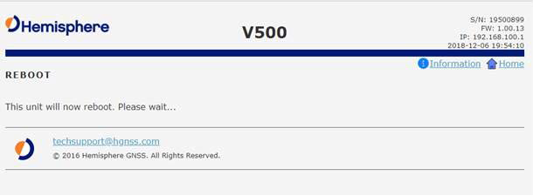

## Overview

# Appendix A: Troubleshooting

|  |  |
| --- | --- |
| **Introduction** | Appendix A provides troubleshooting for common problems. |

**Contents**

|  |  |
| --- | --- |
| **Topic** | **See Page** |
| Troubleshooting | 74 |

## Troubleshooting

**Appendix A troubleshooting**

|  |  |
| --- | --- |
| **Symptom** | **Possible Solution** |
| Receiver fails to power | * Check to see if the power LED is turned on * Verify polarity of power leads * Check integrity of power cable connectors * Check power input voltage (7 to 32 VDC) * Check the voltage from the connector at the end of the cable * Check current restrictions imposed by power source (minimum available should be > 1.0 A) |
| No data from V500 | * Check receiver power status to ensure the receiver is powered * Verify desired messages are activated (using PocketMax4, the WebUI, or $JSHOW command in any terminal program) * Ensure the baud rate of the V500 matches that of the receiving device * Check integrity and connectivity of power and data cable connections |
| Random data from V500 | * Verify that RTCM or binary messages are not being output (use the WebUI to see which messages are turned on) * Ensure the baud rate of the V500 matches that of the remote device * Ensure the requested throughput does not exceed the amount of data allowed by the baud rate of the COM port |
| No GNSS lock | * Verify the V500 has a clear view of the sky * Use PocketMax4 or the WebUI to see how many satellites are in view and the SNR values |

### Table A-1: V500 Troubleshooting

*Continued on next page*

**Appendix A troubleshooting**

|  |  |
| --- | --- |
| **Symptom** | **Possible Solution** |
| No heading or incorrect heading value | * Check CSEP value is constant without varying more than 1 cm (0.39 in)—larger variations may indicate a high multipath environment and require moving the receiver location * $JATT,SEARCH command forces the V500 to acquire a new heading solution (unless gyro is enabled) * Enable GYROAID to provide heading for up to three minutes during GNSS signal loss * Enable TILTAID to reduce heading search times * Monitor the number of satellites and SNR values for both antennas within PocketMax—at least four satellites should have strong SNR values * The V500 calculates heading from the primary to secondary GNSS antenna (the secondary antenna has an arrow underneath). Ensure via the WebUI or PocketMax there is not a heading bias added to the heading solution |

, continued

### Table A-1: V500 Troubleshooting (continued)

*Continued on next page*

**Appendix A troubleshooting**

|  |  |
| --- | --- |
| **Symptom** | **Possible Solution** |
| Constellations | * If the V500 is not using satellites from a specific constellation (such as Galileo or BeiDou), verify the base station supports those constellations. Only satellites used at the base station can be used at the rover * If the V500 is not using satellites from a specific constellation, ensure the $JSIGNAL command has not disabled the missing constellations * Check the WebUI for multi-GNSS activation |
| Atlas Corrections Are Not Working | * Check your subscription end-date in the WebUI * Use the L-band tab to check the frequency and bandwidth of the tracked satellite. We suggest pressing **Auto** to use your position to automatically   tune to the correct frequency for your region |

, continued

**Table A-1: V500 Troubleshooting (continued)**

# Appendix B: Technical Specifications

## Technical Specifications

|  |  |
| --- | --- |
| **Introduction** | Appendix B provides the V500 technical specifications and the V500  certification information. |

**Contents**

|  |  |
| --- | --- |
| **Topic** | **See Page** |
| V500 Technical Specifications | 78 |
| Index | 83 |
| End User License Agreement | 84 |
| Warranty Notice | 88 |

## V500 Technical Specifications

#### V500 GNSS

**receiver**

### Table B-1: V500 GNSS receiver

**V500 accuracy Table B-2: V500 accuracy**

|  |  |
| --- | --- |
| **Item** | **Specification** |
| Receiver type | Vector GNSS RTK Receiver |
| Signal Received | GPS, GLONASS, BeiDou, Galileo, QZSS7, IRNSS7, and Atlas |
| Channels | 1059 |
| GPS Sensitivity | -142 dBm |
| SBAS Tracking | 2-channel, parallel tracking |
| Update Rate | 10 Hz standard, 20 Hz optional |
| Timing (1PPS) Accuracy | 20 ns |
| Rate of Turn | 100˚/s maximum |
| Cold Start | 60 s (no almanac or RTC) |
| Warm Start | 30 s typical (almanac and RTC) |
| Hot Start | 10 s typical (almanac, RTC and position) |
| Heading Fix | 10 s typical (Hot Start) |
| Antenna Input Impedance | 50 Ω |
| Maximum Speed | 1,850 mph (999 kts) |
| Maximum Altitude | 18,288 m (60,000 ft) |
| Differential Options | SBAS, Atlas (L-band), RTK |

|  |  |
| --- | --- |
| **Item** | **Specification** |
| **Positioning** | **RMS (657%) 2DRMS(95%)** |
| Single Point1 | 2.4 m |
| SBAS 2 | 0.6 m |
| Atlas H106 | 0.08 m 0.16m |
| Atlas H30 6 | 0.3 m |
| Atlas Basic6 | 0.5 m |
| RTK 1,3 | 8 mm + 1 ppm 15 mm + 2 ppm |
| Heading (RMS) | < 0.27° |
| Pitch/Roll (RMS) | 1˚ |
| Heave (RMS) | 30 cm (DGPS) 1, 10 cm (Atlas) 1,6, 5 cm  (RTK)6 |

*Continued on next page*

#### V500

**communication s**

|  |  |
| --- | --- |
| **Item** | **Specification** |
| Ports | 1x full-duplex RS-232/RS-422, , 1x RS-232, 2x  CAN, 1x Ethernet |
| Baud rates | 4800 - 115200 |
| Radio Interfaces | Bluetooth 2.0 (Class 2), Wi-Fi 2.4 GHz |
| Correction I/O  protocol | Hemisphere GNSS proprietary ROX format,  RTCMv2.3, RTCM v3.2, CMR8, CMR+ 8 |
| Data I/O protocol | NMEA 0183, Hemisphere GNSS binary |
| Timing Output | 1PPS, CMOS, falling edge sync |
| Event Marker Input | Open drain, falling edge sync, 10 kΩ, 10 pF load |

### Table B-3: V500 communications

**V500 power Table B-4: V500 power**

|  |  |
| --- | --- |
| **Item** | **Specification** |
| Input voltage | 9 - 32 VDC |
| Power consumption | 7.5W maximum |
| Current consumption | 1.8A maximum |
| Power Isolation | No |
| Reverse Polarity  Protection | Yes |

*Continued on next page*

#### V500

**environmental**

#### V500

**mechanical**

### Table B-5: V500 environmental

|  |  |
| --- | --- |
| **Item** | **Specification** |
| Operating temperature | -40°C to +70°C (-40°F to +158°F) |
| Storage temperature | -40°C to +85°C (-40°F to +185°F) |
| Humidity | 95% non-condensing |
| Vibration | ISO 16750-3:2012  Section 4.1.2.7 Table 12  IEC 60945 Section 8.7 |
| EMC | IEC60945:2002  EN 301 489-1 V2.1.1  EN 301 489-5 V2.1.1  EN 301 489-19 V2.1.0  EN 301 489-17 3.1.1  EN 303 413 V1.1.1 |
| IMO Wheelmark Certification | No |
| Enclosure | IPx7/IPx9K |

**Table B-6: V500 mechanical**

|  |  |
| --- | --- |
| **Item** | **Specification** |
| Dimensions | 68.6 L x 22.0 W x 12.3 H cm  27.0 L x 8.7 W x 4.8 H (in) |
| Weight | 3.7 kg (8.2 lb) |
| Status indications (LED) | Power, GNSS Lock, Heading |
| Power/Data connector | 22-Pin environmentally sealed |

*Continued on next page*

**V500 L-band receiver**

**V500 Aiding devices**

### Table B-7: V500 L-band receiver

|  |  |
| --- | --- |
| **Item** | **Specification** |
| Channels | 1525 to 1560 MHz |
| Sensitivity | -130 dBm |
| Channel Spacing | 5 kHz |
| Satellite Selection | Manual or Automatic |
| Reacquisition Time | 15 sec (typical) |

**Table B-8: Aiding devices**

|  |  |
| --- | --- |
| **Device** | **Description** |
| Gyro | Provides smooth heading, fast heading reacquisition and  reliable < 0.1° per min heading for periods up to 3 min. when loss of GPS has occurred 4 |
| Tilt Sensors | Provide pitch, roll data and assist in fast start-up and  reacquisition of heading solution |

1Depends on multipath environment, number of satellites in view, satellite geometry, no SA, and ionospheric activity

2Depends on multipath environment, number of satellites in view, WAAS coverage and satellite geometry

3Depends on multipath environment, number of satellites in view, satellite geometry, baseline length (for differential services), and ionospheric activity

4Based on a 40 second time constant

5Hemisphere GNSS proprietary

6Requires a Hemisphere GNSS subscription

7With future firmware upgrade and activation

8CMR and CMR+ do not cover proprietary messages outside of the typical standard

## Index

1PPS 6

**Activate Loader** 18, 19

Activation 6

### Age of Differential 54

Atlas 6, 13, 39, 40, 42, 54, 58, 70

Atlas Datum 70

Base Station 6

Baud Rates 34

BeiDou 6, 42

Bluetooth 51, 59, 66, 70, 71

Configuration 59

### Convergence time 13

course-over-ground 45, 62

Course-Over-Ground (COG 47

CSEP 65

DGPS/DGNSS 6

Differential Corrections 6

### Differential Source 54

Elevation Mask 7

environmental 21, 22

Ephemeris 69

Ethernet 32, 59, 60

File Splitting 68

firmware 15, 16, 17, 18, 19, 32, 52

Firmware 7, 15, 16, 17, 18, 19, 53

Flush-mount 25

GALILEO 7

GGA 68, 69

GLONASS 7, 12, 42

GPS 6, 7, 8, 42

Gyro aiding 44, 45, 63

**HDOP** 54

Heading .7, 12, 46, 50, 52, 55, 59, 62, 63, 64,

65, 69

### HPR values 23

HTAU 45, 46, 64

### LED indicators 50

Logging 59, 67, 68, 69

long site alignment 25

Message Types 34

Multipath 8

NMEA 8, 54, 61

Now/Forever 67

Parallel orientation 22

Perpendicular orientation 22

Pitch 46, 55, 63

### Pole-mount 25

Position 52

Position Velocity 68

### Positioning accuracy 13

### Positioning sustainability 13

Power/Data cable 28, 35

### Program Type 17

Rate-of-Turn 45

Rate-of-Turn (ROT) 45, 46

Reboot 72

Receiver mode 57

Receiver Mode 58

RightArm 15, 16, 17, 18, 19

**Rover** 58

ROX 8

RS-422 32, 33, 34

RTCM 58, 74

RTK 6, 8, 12, 13, 39, 40, 41, 43, 44, 45, 52,

54, 63, 70

RX Info 52

### Satellites Used 54

SBAS 8, 9, 39, 40, 49, 52, 57

### Scalable service levels 13

Serial Output 61

Serial port configuration 33

Serial ports 32, 79

Short site alignment 25

### SmartLink 58

### Solution Type 54

SPDTAU 65

Speed 47, 55, 65, 69

Status 18, 52, 80

Subscription 6, 8, 53

Tilt Aiding 43, 63

WAAS .......................................................... 9 WebUI 15, 34, 51, 66, 74

|  |  |
| --- | --- |
| **End User license**  **agreement** | **IMPORTANT** - This is an agreement (the "**Agreement**") between you, the end purchaser ("**Licensee**") and  Hemisphere GNSS Inc. ("**Hemisphere**") which permits Licensee to use the Hemisphere software (the "**Software**") that accompanies this Agreement. This Software may be licensed on a standalone basis or may be embedded in a Product. Please read and ensure that you understand this Agreement before installing or using the Software Update or using a Product.  In this agreement any product that has Software embedded in it at the time of sale to the Licensee shall be referred to as a "**Product**". As well, in this Agreement, the use of a Product shall be deemed to be use of the Software which is embedded in the Product.  BY INSTALLING OR USING THE SOFTWARE UPDATE OR THE PRODUCT, LICENSEE THEREBY AGREES TO BE LEGALLY BOUND BY THE TERMS OF THIS AGREEMENT. IF YOU DO NOT AGREE TO THESE TERMS, (I) DO NOT INSTALL OR USE THE SOFTWARE, AND (II) IF YOU ARE INSTALLING AN UPDATE TO THE SOFTWARE, DO NOT INSTALL THE UPDATE AND PROMPTLY DESTROY IT.  HEMISPHERE PROVIDES LIMITED WARRANTIES IN RELATION TO THE SOFTWARE. AS WELL, THOSE WHO USE THE EMBEDDED SOFTWARE DO SO AT THEIR OWN RISK. YOU SHOULD UNDERSTAND THE IMPORTANCE OF THESE AND OTHER LIMITATIONS SET OUT IN THIS AGREEMENT BEFORE INSTALLING OR USING THE SOFTWARE OR THE PRODUCT.  1. **LICENSE**. Hemisphere hereby grants to Licensee a non-transferable and non-exclusive license to use the Software as embedded in a Product and all Updates (collectively the "**Software**"), solely in binary executable form.  2. **RESTRICTIONS ON USE**. Licensee agrees that Licensee and its employees will not directly or indirectly, in any manner whatsoever:  a. install or use more copies of the Software than the number of copies that have been licensed;  b. use or install the Software in connection with any product other than the Product the Software was intended to be used or installed on as set out in the documentation that accompanies the Software.  c. copy any of the Software or any written materials for any purpose except as part of Licensee's normal backup processes;  d. modify or create derivative works based on the Software;  e. sub-license, rent, lease, loan or distribute the Software;  f. permit any third party to use the Software;  g. use or operate Product for the benefit of any third party in any type of service outsourcing, application service, provider service or service bureau capacity;  h. reverse engineer, decompile or disassemble the Software or otherwise reduce it to a human perceivable form;  i. Assign this Agreement or sell or otherwise transfer the Software to any other party except as part of the sale or transfer of the whole Product.  3. **UPDATES**. At Hemisphere's discretion Hemisphere may make Updates available to Licensee. An update ("**Update**") means any update to the Software that is made available to Licensee including error corrections, enhancements and other modifications. Licensee may access, download and install Updates during the Warranty Period only. All Updates that Licensee downloads, installs or uses shall be deemed to be Software and subject to this Agreement. Hemisphere reserves the right to modify the Product without any obligation to notify, supply or install any improvements or alterations to existing Software.  4. **SUPPORT.** Hemisphere may make available directly or through its authorized dealers telephone and email support for the Software. Contact Hemisphere to find the authorized dealer near you. As well, Hemisphere may make available user and technical documentation regarding the Software. Hemisphere reserves the right to reduce and limit access to such  support at anytime. |

|  |  |
| --- | --- |
| **End User license**  **agreement**, continued | 5. **BACKUPS AND RECOVERY.** Licensee shall back-up all data used, created or stored by the  Software on a regular basis as necessary to enable proper recovery of the data and related systems and processes in the event of a malfunction in the Software or any loss or corruption of data caused by the Software. Licensee shall assume all risks of loss or damage for any failure to comply with the foregoing.  6. **OWNERSHIP.** Hemisphere and its suppliers own all rights, title and interest in and to the Software and related materials, including all intellectual property rights. The Software is licensed to Licensee, not sold.  7. **TRADEMARKS**. "Hemisphere GNSS", "Crescent", "Eclipse" and the associated logos are trademarks of Hemisphere. Other trademarks are the property of their respective owners. Licensee may not use any of these trademarks without the consent of their respective owners.  8. **LIMITED WARRANTY**. Hemisphere warrants solely to the Licensee, subject to the exclusions and procedures set forth herein below, that for a period of one (1) year from the original date of purchase of the Product in which it is embedded (the "Warranty Period"), the Software, under normal use and maintenance, will conform in all material respects to the documentation provided with the Software and any media will be free of defects in materials and workmanship. For any Update, Hemisphere warrants, for 90 days from performance or delivery, or for the balance of the original Warranty Period, whichever is greater, that the Update, under normal use and maintenance, will conform in all material respects to the documentation provided with the Update and any media will be free of defects in materials and workmanship. Notwithstanding the foregoing, Hemisphere does not warrant that the Software will meet Licensee's requirements or that its operation will be error free.  9. **WARRANTY EXCLUSIONS**. The warranty set forth in Section (8) will not apply to any deficiencies caused by (a) the Product not being used as described in the documentation supplied to Licensee, (b) the Software having been altered, modified or converted in any way by anyone other than Hemisphere approved by Hemisphere, (c) any malfunction of Licensee's equipment or other software, or (d) damage occurring in transit or due to any accident, abuse, misuse, improper installation, lightning (or other electrical discharge) or neglect other than that caused by Hemisphere. Hemisphere GNSS does not warrant or guarantee the precision or accuracy of positions obtained when using the Software (whether standalone or embedded in a Product). The Product and the Software is not intended and should not be used as the primary means of navigation or for use in safety of life applications. The potential positioning and navigation accuracy obtainable with the Software as stated in the Product or Software documentation serves to provide only an estimate of achievable accuracy based on specifications provided by the US Department of Defense for GPS positioning and DGPS service provider performance specifications, where applicable.  10. **WARRANTY DISCLAIMER.** EXCEPT AS EXPRESSLY SET OUT IN THIS AGREEMENT, HEMISPHERE MAKES NO REPRESENTATION, WARRANTY OR CONDITION OF ANY KIND TO LICENSEE, WHETHER VERBAL OR WRITTEN AND HEREBY DISCLAIMS ALL REPRESENTATIONS, WARRANTIES AND CONDITIONS OF ANY KIND INCLUDING FITNESS FOR A PARTICULAR PURPOSE, MERCHANTABILITY, ACCURACY, RELIABILITY OR THAT THE USE OF THE SOFTWARE WILL BE UNINTERRUPTED OR ERROR-FREE AND HEREBY DISCLAIMS ALL REPRESENTATIONS, WARRANTIES AND CONDITIONS ARISING AS A RESULT OF CUSTOM, USAGE OR TRADE AND THOSE ARISING UNDER STATUTE.  11. **LIMITS ON WARRANTY DISCLAIMER.** Some jurisdictions do not allow the exclusion of implied warranties or conditions, so some of the above exclusions may not apply to Licensee. In that case, any implied warranties or conditions which would then otherwise arise will be limited in duration to ninety (90) days from the date of the license of the Software or the purchase of the Product. The warranties given herein give Licensee specific legal rights and Licensee may have other rights which may vary from jurisdiction to jurisdiction.  12. **CHANGE TO WARRANTY.**No employee or agent of Hemisphere is authorized to change the warranty provided or the limitation or disclaimer of warranty provisions. All such changes will only be effective if pursuant to a separate agreement signed by senior officers of the  respective parties. |

|  |  |
| --- | --- |
| **End User license**  **agreement**, continued | 13. **WARRANTY CLAIM.** In the event Licensee has a warranty claim Licensee must first check for  and install all Updates that are made available. The warranty will not otherwise be honored. Proof of purchase may be required. Hemisphere does not honor claims asserted after the end of the Warranty Period.  14. **LICENSEE REMEDIES.** In all cases which involve a failure of the Software to conform in any material respect to the documentation during the Warranty Period or a breach of a warranty, Hemisphere's sole obligation and liability, and Licensee's sole and exclusive remedy, is for Hemisphere, at Hemisphere's option, to (a) repair the Software, (b) replace the Software with software conforming to the documentation, or (c) if Hemisphere is unable, on a reasonable commercial basis, to repair the Software or to replace the Software with conforming software within ninety (90) days, to terminate this Agreement and thereafter Licensee shall cease using the Software. Hemisphere will also issue a refund for the price paid by Licensee less an amount on account of amortization, calculated on a straight-line basis over a deemed useful life of three (3) years.  15. LIMITATION OF LIABILITY. IN NO EVENT WILL HEMISPHERE BE LIABLE TO LICENSEE FOR ANY INCIDENTAL, CONSEQUENTIAL, SPECIAL OR INDIRECT DAMAGES INCLUDING ARISING IN RELATION TO ANY LOSS OF DATA, INCOME, REVENUE, GOODWILL OR ANTICIPATED SAVINGS EVEN IF HEMISPHERE HAS BEEN INFORMED OFTHE POSSIBILITY OF SUCH LOSS OR DAMAGE. FURTHER, IN NO EVENT WILL HEMISPHERE'S TOTAL CUMULATIVE LIABILITY HEREUNDER, FROM ALL CAUSES OF ACTION OF ANY KIND, EXCEED THE TOTAL AMOUNT PAID BY LICENSEE TO HEMISPHERE TO PURCHASE THE PRODUCT. THIS LIMITATION AND EXCLUSION APPLIES IRRESPECTIVE OF THE CAUSE OF ACTION, INCLUDING BUT NOT LIMITED TO BREACH OF CONTRACT, NEGLIGENCE, STRICT LIABILITY, TORT, BREACH OF WARRANTY, MISREPRESENTATION OR ANY OTHER LEGAL THEORY AND WILL SURVIVE A FUNDAMENTAL BREACH.  16. LIMITS ON LIMITATION OF LIABILITY. Some jurisdictions do not allow for the limitation or exclusion of liability for incidental or consequential damages, so the above limitation or exclusion may not apply to Licensee and Licensee may also have other legal rights which may vary from jurisdiction to jurisdiction.  17. BASIS OF BARGAIN. Licensee agrees and acknowledges that Hemisphere has set its prices and the parties have entered into this Agreement in reliance on the limited warranties, warranty disclaimers and limitations of liability set forth herein, that the same reflect an agreed-to allocation of risk between the parties (including the risk that a remedy may fail of its essential purpose and cause consequential loss), and that the same forms an essential basis of the bargain between the parties. Licensee agrees and acknowledges that Hemisphere would not have been able to sell the Product at the amount charged on an economic basis without such limitations.  18. PROPRIETARY RIGHTS INDEMNITY. Hemisphere shall indemnify, defend and hold harmless Licensee from and against any and all actions, claims, demands, proceedings, liabilities, direct damages, judgments, settlements, fines, penalties, costs and expenses, including royalties and attorneys' fees and related costs, in connection with or arising out of any actual infringement of any third party patent, copyright or other intellectual property right by the Software or by its use, in accordance with this Agreement and documentation, PROVIDED THAT: (a) Hemisphere has the right to assume full control over any action, claim, demand or proceeding, (b) Licensee shall promptly notify Hemisphere of any such action, claim, demand, or proceeding, and (c) Licensee shall give Hemisphere such reasonable assistance and tangible material as is reasonably available to Licensee for the defense of the action, claim, demand or proceeding. Licensee shall not settle or compromise any of same for which Hemisphere has agreed to assume responsibility without Hemisphere's prior written consent. Licensee may, at its sole cost and expense, retain separate counsel from the counsel utilized or retained by Hemisphere. 19. INFRINGEMENT. If use of the Software may be enjoined due to a claim of infringement by a third party then, at its sole discretion and expense, Hemisphere may do one of the following: (a) negotiate a license or other agreement so that the Product is no longer subject to such a potential claim, (b) modify the Product so that it becomes non- infringing, provided such modification can be accomplished without materially affecting the  performance and functionality of the Product, |

|  |  |
| --- | --- |
| **End User license**  **agreement**, continued | (c) replace the Software, or the Product, with non-infringing software, or product, of equal or  better performance and quality, or (d) if none of the foregoing can be done on a commercially reasonable basis, terminate this license and Licensee shall stop using the Product and Hemisphere shall refund the price paid by Licensee less an amount on account of amortization, calculated on a straight-line basis over a deemed useful life of three (3) years.  19. The foregoing sets out the entire liability of Hemisphere and the sole obligations of Hemisphere to Licensee in respect of any claim that the Software or its use infringes any third party rights.  20. INDEMNIFICATION. Except in relation to an infringement action, Licensee shall indemnify and hold Hemisphere harmless from any and all claims, damages, losses, liabilities, costs and expenses (including reasonable fees of lawyers and other professionals) arising out of or in connection with Licensee's use of the Product, whether direct or indirect, including without limiting the foregoing, loss of data, loss of profit or business interruption. TERMINATION. Licensee may terminate this Agreement at any time without cause. Hemisphere may terminate this Agreement on 30 days notice to Licensee if Licensee fails to materially comply with each provision of this Agreement unless such default is cured within the 30 days. Any such termination by a party shall be in addition to and without prejudice to such rights and remedies as may be available, including injunction and other equitable remedies. Upon receipt by Licensee of written notice of termination from Hemisphere or termination by Licensee, Licensee shall at the end of any notice period (a) cease using the Software; and (b) return to Hemisphere (or destroy and provide a certificate of a Senior Officer attesting to such destruction) the Software and all related material and any magnetic or optical media provided to Licensee. The provisions of Sections 6), 7), 8), 9), 10), 15), 21), 26) and 27) herein shall survive the expiration or termination of this Agreement for any reason.  21. **EXPORT RESTRICTIONS**. Licensee agrees that Licensee will comply with all export control legislation of Canada, the United States, Australia and any other applicable country's laws and regulations, whether under the Arms Export Control Act, the International Traffic in Arms Regulations, the Export Administration Regulations, the regulations of the United States Departments of Commerce, State, and Treasury, or otherwise as well as the export control legislation of all other countries.  22. **PRODUCT COMPONENTS.** The Product may contain third party components. Those third party components may be subject to additional terms and conditions. Licensee is required to agree to those terms and conditions in order to use the Product.  23. **FORCE MAJEURE EVENT.** Neither party will have the right to claim damages as a result of the other's inability to perform or any delay in performance due to unforeseeable circumstances beyond its reasonable control, such as labor disputes, strikes, lockouts, war, riot, insurrection, epidemic, Internet virus attack, Internet failure, supplier failure, act of God, or governmental action not the fault of the non-performing party.  24. **FORUM FOR DISPUTES**. The parties agree that the courts located in Calgary, Alberta, Canada and the courts of appeal there from will have exclusive jurisdiction to resolve any disputes between Licensee and Hemisphere concerning this Agreement or Licensee's use or inability to use the Software and the parties hereby irrevocably agree to attorn to the jurisdiction of those courts. Notwithstanding the foregoing, either party may apply to any court of competent jurisdiction for injunctive relief.  25. **APPLICABLE LAW**. This Agreement shall be governed by the laws of the Province of Alberta, Canada, exclusive of any of its choice of law and conflicts of law jurisprudence.  26. **CISG.** The United Nations Convention on Contracts for the International Sale of Goods will not apply to this Agreement or any transaction hereunder.  **GENERAL.** This is the entire agreement between Licensee and Hemisphere relating to the Product and Licensee's use of the same, and supersedes all prior, collateral or contemporaneous oral or written representations, warranties or agreements regarding the same. No amendment to or modification of this Agreement will be binding unless in writing and signed by duly authorized representatives of the parties. Any and all terms and conditions set out in any correspondence between the parties or set out in a purchase order which are different from or in addition to the terms and conditions set forth herein, shall have no application and no written notice of same shall be required. In the event that one or more of the provisions of this Agreement is found to be illegal or unenforceable, this Agreement shall not be rendered inoperative but the remaining provisions shall continue in  full force and effect. |

|  |  |
| --- | --- |
| **Warranty notice** | **COVERED PRODUCTS:** This warranty covers all products manufactured by Hemisphere GNSS and purchased by  the end purchaser (the "Products"), unless otherwise specifically and expressly agreed in writing by Hemisphere GNSS.  **LIMITED WARRANTY:** Hemisphere GNSS warrants solely to the end purchaser of the Products, subject to the exclusions and procedures set forth below, that the Products sold to such end purchaser and its internal components shall be free, under normal use and maintenance, from defects in materials, and workmanship and will substantially conform to Hemisphere GNSS's applicable specifications for the Product, for a period of 12 months from delivery of such Product to such end purchaser (the ”Warranty Period”). Repairs and replacement components for the Products are warranted, subject to the exclusions and procedures set forth below, to be free, under normal use and maintenance, from defects in material and workmanship, and will substantially conform to Hemisphere GNSS's applicable specifications for the Product, for 90 days from performance or delivery, or for the balance of the original Warranty Period, whichever is greater.  **EXCLUSION OF ALL OTHER WARRANTIES.** The LIMITED WARRANTY shall apply only if the Product is properly and correctly installed, configured, interfaced, maintained, stored, and operated in accordance with Hemisphere GNSS relevant User’s Manual and Specifications, AND the Product is not modified or misused. The Product is provided “AS IS” and the implied warranties of MERCHANTABILITY and FITNESS FOR A PARTICULAR PURPOSE and ALL OTHER WARRANTIES,  express, implied or arising by statute, by course of dealing or by trade usage, in connection with the design, sale, installation, service or use of any products or any component thereof, are EXCLUDED from this transaction and shall not apply to the Product. The LIMITED WARRANTY is IN LIEU OF any other warranty, express or implied, including but not limited to, any warranty of MERCHANTABILITY or FITNESS FOR A PARTICULAR PURPOSE, title, and non-infringement.  **LIMITATION OF REMEDIES.** The purchaser’s EXCLUSIVE REMEDY against Hemisphere GNSS shall be, at Hemisphere GNSS's option, the repair or replacement of any defective Product or components thereof. The purchaser shall notify Hemisphere GNSS or a Hemisphere GNSS's approved service center immediately of any defect. Repairs shall be made through a Hemisphere GNSS approved service center only. Repair, modification or service of Hemisphere GNSS products by any party other than a Hemisphere GNSS approved service center shall render this warranty null and void. The remedy in this paragraph shall only be applied in the event that the Product is properly and correctly installed, configured, interfaced, maintained, stored, and operated in accordance with Hemisphere GNSS's relevant User’s Manual and Specifications, AND the Product is not modified or misused. NO OTHER REMEDY (INCLUDING, BUT NOT LIMITED TO, SPECIAL, INDIRECT, INCIDENTAL, CONSEQUENTIAL OR CONTINGENT DAMAGES FOR LOST PROFITS, LOST SALES, INJURY TO PERSON OR PROPERTY, OR ANY OTHER INCIDENTAL OR CONSEQUENTIAL LOSS) SHALL BE AVAILABLE  TO PURCHASER, even if Hemisphere GNSS has been advised of the possibility of such damages. Without limiting the foregoing, Hemisphere GNSS shall not be liable for any damages of any kind resulting from installation, use, quality, performance or accuracy of any Product.  **HEMISPHERE IS NOT RESPONSIBLE FOR PURCHASER’S NEGLIGENCE OR UNAUTHORIZED USES OF THE PRODUCT.** IN NO EVENT SHALL Hemisphere GNSS BE IN ANY WAY RESPONSIBLE FOR ANY DAMAGES RESULTING FROM PURCHASER’S OWN NEGLIGENCE, OR FROM OPERATION OF THE PRODUCT IN ANY WAY OTHER THAN AS SPECIFIED IN Hemisphere GNSS's RELEVANT USER’S MANUAL AND SPECIFICATIONS. Hemisphere GNSS is NOT  RESPONSIBLE for defects or performance problems resulting from (1) misuse, abuse, improper installation, neglect of Product; (2) the utilization of the Product with hardware or software products, information, data, systems, interfaces or devices not made, supplied or specified by Hemisphere GNSS; (3) the operation of the Product under any specification other than, or in addition to, the specifications set forth in Hemisphere GNSS's relevant User’s Manual and Specifications; (4) damage caused by accident or natural events, such as lightning (or other electrical discharge) or fresh/ salt water immersion of Product; (5) damage occurring in transit; (6) normal wear and tear; or (7) the operation or failure of operation of any satellite-based positioning system or differential correction service; or the availability or performance of any satellite-based positioning signal or differential correction signal.  **THE PURCHASER IS RESPONSIBLE FOR OPERATING THE VEHICLE SAFELY.** The purchaser is solely responsible for the safe operation of the vehicle used in connection with the Product, and for maintaining proper system control settings. UNSAFE DRIVING OR SYSTEM CONTROL SETTINGS CAN RESULT IN PROPERTY DAMAGE, INJURY, OR  DEATH. |

*Continued on next page*

|  |  |
| --- | --- |
| **Warranty**  **notice**, continued | The purchaser is solely responsible for his/her safety and for the safety of others. The purchaser is solely  responsible for maintaining control of the automated steering system at all times. THE PURCHASER IS SOLELY RESPONSIBLE FOR ENSURING THE PRODUCT IS PROPERLY AND CORRECTLY INSTALLED, CONFIGURED, INTERFACED, MAINTAINED, STORED, AND OPERATED IN ACCORDANCE WITH Hemisphere GNSS's RELEVANT  USER’S MANUAL AND SPECIFICATIONS. Hemisphere GNSS does not warrant or guarantee the positioning and navigation precision or accuracy obtained when using Products. Products are not intended for primary navigation or for use in safety of life applications. The potential accuracy of Products as stated in Hemisphere GNSS literature and/or Product specifications serves to provide only an estimate of achievable accuracy based on performance specifications provided by the satellite service operator (i.e. US Department of Defense in the case of GPS and differential correction service provider. Hemisphere GNSS reserves the right to modify Products without any obligation to notify, supply or install any improvements or alterations to existing Products.  **GOVERNING LAW.** This agreement and any disputes relating to, concerning or based upon the Product shall be governed by and interpreted in accordance with the laws of the State of Arizona.  **OBTAINING WARRANTY SERVICE.** In order to obtain warranty service, the end purchaser must bring the Product to a Hemisphere GNSS approved service center along with the end purchaser's proof of purchase. Hemisphere GNSS does not warrant claims asserted after the end of the warranty period. For any questions regarding warranty service or to obtain information regarding the location of any of Hemisphere GNSS approved service center, contact Hemisphere GNSS at the following address:  **Hemisphere GNSS**  8515 E. Anderson Drive Scottsdale, AZ 85255, USA Phone: +1-480-348-6380  Fax: +1-480-270-5070  [TECHSUPPORT@HREGNSS.COM](mailto:techsupport@hregnss.com) [WWW.HGNSS.COM](http://www.hgnss.com/) |



Hemisphere GNSS Inc.

8515 East Anderson Drive, Suite A Scottsdale, Arizona, US 85255 Phone: 480-348-6380

Fax: 480-270-5070

[PRECISION@HGNSS.COM](mailto:precision@hgnss.com) [WWW.HGNSS.COM](http://www.hgnss.com/)